**Electrophysiology Analysis Optimization using Intan Technologies**

Documentation and Protocol presented

by

Baihan Lin

to

Olavarria Lab

Department of Psychology

in partial fulfillment of the data analysis task

in the subject of

Computational Neuroscience

University of Washington

Seattle, Washington, USA

Apr 2016

**Mentors:**

Prof. Jaime Olavarria

Dr. Adrian Andelin

**Author:**

Baihan Lin

**Abstract:**

The thesis is given birth due to the need to analyze a set of electrophysiology recording data and the curiosity of finding the best way to generate and present the result, and to simplify the entire electrophysiology analysis in a simple automated protocol. Comparing to the traditional method, which spends 17640 minutes (~300 hours) to analyze the 441 cases of data files in our current stage, my method only takes less than 10 minutes, which is 1764 times faster and saves 300 hours. I hope this method described in this documentation can offer a more systematic and convenient way in the anlaysis of electrophysiology recording data. I look forward to further improvements if any. After tens of hours of my working each week to develop this automated protocol, I hope lab members in the future can simply run the program in 10 minutes to save their time and lives.

**Comment:**

This documentation is mainly for the purpose of recording my thoughts and attempts in optimizing the data analysis task, therefore not in a standard of submission in any kind.

**Keyword:**

MATLAB, protocol, electrophysiology experiments, Mac terminal, Intan Technologies

**Contents:**

**Abstract …………………………………………………………………………………. 2**

**Keywords ……………………………………………………………………………….. 2**

1. **Traditional Solution:** (Challenges Faced)……………. ………………………….…**5**
   1. Darking/Contrasting Process
   2. Utilization of Gaussian Blurring via ImageJ or Photoshop
   3. Arbitrary Drawing of line in the V1

1. **Task 1: Indicating Patch Index** (Java, ImageJ, MATLAB, Patch Analyst) ……….. ...**6**
   1. Solution 1: Implementing the traditional (via Java or MATLAB)
   2. Solution 2: Patch analysis via Patch Analyst (New possible alternative)
   3. Solution 3: Particle analysis via ImageJ (New possible alternative)
   4. Solution 4: width of line (Improvement on traditional)
   5. Solution 5: Cluster Index (New possible alternative)
   6. Solution 6: Machine Learning (New possible alternative)
2. **Task 2: Optimizing the data:** (ImageJ, Excel, Java, MATLAB)…………………...... **9**
   1. Standardization
   2. Smoothing Method (Moving Average):
      1. Excel (Exploration)
      2. Java (Implementation)
      3. MATLAB (Outlook)
3. **Task 3: Systematization:** (systematize the protocol more efficiently) …………….**13**
   1. Automatic file reading and processing
   2. Visual user-friendly version
   3. Automatic software operation
   4. Patch Processor (a Software designed by Baihan Lin)
4. **Method Validation** ………………………………………………………………... **22**
5. **Future Improvements** ……………………………………………………………. **23**
6. **Data Summary** …........................................…………………………………….... **24**
   1. Data Charts
   2. Excel Smoothing Plot (as an indication of the validity of SF = 10/364)
   3. ImageJ Plots & Lines (line & line with width of 100)
7. **Code Summary** (20 Java programs)…….………..………………...…………….. **33**
   1. **First Attempt** (using TreeMap)
      1. MapPatchIndexMain.java (main method)
      2. MapPatchIndexSolver.java (subprogram)
   2. **Better Solution** (using ArrayList)
      1. PatchIndexMain.java (main method)
      2. PatchIndexSolver.java (subprogram)
   3. **Smooth Factor Finder** (test different smooth factor to find the most proper)
      1. SmoothPatchIndexMain.java (main method)
      2. PatchIndexSolver.java (subprogram)
   4. **Automatic System** (read-all files in a folder)
      1. AutoPatchIndexMain.java (main method)
      2. PatchIndexSolver.java (subprogram)
   5. **Attempt to visualize** (output the system console, failed)
      1. AutoPatchIndexMainBackUp.java (main method)
      2. PatchIndexSolver.java (subprogram)
      3. ConsoleTextArea.java (subprogram)
      4. LoopedStreams.java (subprogram)
   6. **Second Attempt to visualize** (user-friendly, using acm.jar and JComponent)
      1. VisualPatchIndexMain.java (main method)
      2. VisualPatchIndexSolver.java (subprogram)
   7. **Standard Java File** (standardize, exportable to jar, then to exe)
      1. VisualPatchProcessorMain.java (main method) with jar/exe
      2. VisualPatchIndexSolver.java (subprogram)
   8. **Version 2.0** (with excel export, smooth factor and imageJ functions, browse)
      1. VEPatchProcessorMain.java (main method) with jar/exe
      2. ExcelFileDealer.java (subclass)
      3. PISolver.java (subclass)
      4. ImageJ.java (revised subclass)

**Bibliography ………………………………………………………………………..... 130**

**Special Acknowledgement …...…………………………………………………….... 131**

**Code Summary:**

(in order of importance from high to low)

1. **fast_160504_IntanEphysAnalysis.m**
2. **fast_arrange_Intan_RHD.m**
3. **final_160430_IntanEphysAnalysis.m**
4. **arrange_Intan_RHD.m**
5. **success_160426_IntanEphysAnalysis.m**
6. **all_160421_IntanEphysAnalysis.m**
7. **read_Intan_RHD_combine.m**
8. **backup_160407_IntanEphysAnalysis.m**
9. **backup_IntanEphysAnalysis_033016_Original.m**
10. **read_Intan_RHD2000_file.m**
11. **comment_160330_IntanEphysAnalysis.m**

**Work Progress:**

**(What, when and how I approached the project)**

I used MATLAB and GitHub to perform my project, because it seems previously I programmed a lot but never kept record for it. Working at night and other irregular hours, I found it sad that these attempts and efforts are sometimes untracked. Thus, I introduced this to ensure my attempts are tracked for my own record.

During the project, I reported weekly and communicated with Dr. Adrian Andelin in emails times (). From GitHub, I made at least commits (major adjustments of codes), created versions of analysis code for differnet purposes.

From the GitHub daily coding graph (Figure ), I worked continuously for this new analysis project every week for tens of hours from April 13th 2016 when I was introduced to the traditional method.

From the GitHub coding punch card (Figure ), it seems I coded for this project spread out the days, mostly at night and early morning. This might be odd but to me, coding at night is the most productive since I found it serene and focusing.

In summary, I put in considerable amount of effort and time into this project, and I really value the trust and responsibilities Prof. Olavarria and Dr. Adrian gave me. I sincerely hope my endeavor and effort do help facilitate the analysis in our lab!

Using my method, running the whole MATLAB analysis for all 441 cases can be accomplished within 10 minutes (normally 5 minutes is sufficient), with only one click and a wait for 10 minutes before viewing our products in specific folders. Comparing to the traditional method costing 17640 minutes, my method is 1764 times faster and saves almost 300 hours of work!

Here is the GitHub repository of all the codes and my progress (Figure ): <https://github.com/doerlbh/OLab_IntanEphys/>

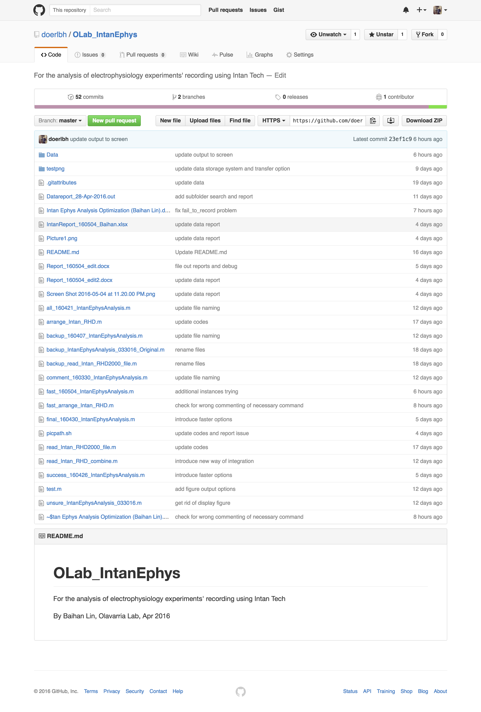

Figure . Screenshot of GitHub repository on May 8th, 2016

**Problem Identification:**

**(What to do)**

To study the effect of sensory deprivation on brain development, Using a combination of transneuronal tracing, in situ hybridization for the immediate early gene Zif268 and electrophysiological recordings, our lab recently showed that the primary visual cortex (V1) in pigmented rats has ODCs, and these ODCs correlate with callosal inputs from the opposite hemispheres. Using similar methods, my project aims to understand the effect of monocular deprivation (MD) on the newly discovered system of ODCs in rat visual cortex. However, introducing a new system of electrophysiology, RHD2000 Amplifier Evaluation System by Intan Technologies, we need a new way of analyzing its corresponding data format.

The RHD2000 Amplifier Evaluation System is a modular family of open-source hardware and software that allows users to record biopotential signals from up to 256 low-noise amplifier channels using RHD2000 digital electrophysiology chips from Intan Technologies. As shown in Figure , A USB interface board connects to a host computer via a standard USB cable. Small amplifier boards connect to the interface board via thin, flexible all-digital cables that may be daisy-chained to form robust connections up to 10 meters in length.



Figure , RHD2000 Amplifier Evaluation System

As shown in Figure , Open-source, multi-platform GUI software controls the operation of the amplifiers and streams data to the screen and to disk in real time at user-selected sampling rates from 1 kS/s to 30 kS/s.

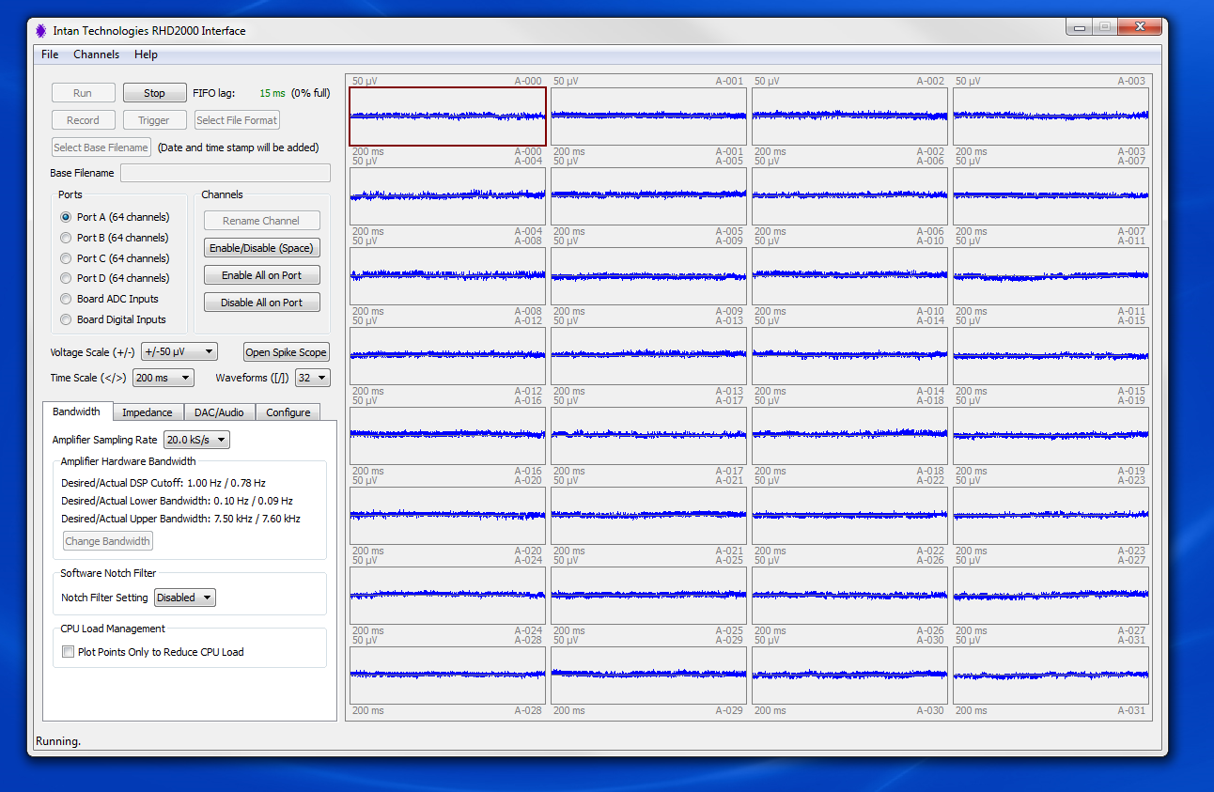

Figure , RHD2000 GUI interface

The RHD2000 Evaluation System allows users to perform the following functions:

* Monitor and record live signals from 16 to 256 low-noise amplifier channels using RHD2000 biopotential amplifier chips.
* Reconfigure amplifier bandwidths and sampling rates from software.
* Measure in situ electrode impedances (both magnitude and phase) at arbitrary frequencies with the click of a button.
* Use eight on-board digital-to-analog converters (DACs) to reconstruct analog waveforms from selected amplifier channels with <1 ms latency.
* Monitor audio of any two amplifier signals using a stereo "line out" jack.
* Record up to eight auxiliary analog inputs and 16 digital inputs synchronized with amplifier data.

These generated binary datasets which cannot be interpreted easily. And we need to use MATLAB in order to decipher the information and perform our customized analysis.

**Traditional Solution:**

**(Work but still room)**

The traditional solution developed by Intan Technologies and Dr. Adrian Andelin consists of two parts: reading the binary datasets and plotting with analysis.

**Step 1: generate Intan “.rhd” files**

From the RHD2000 Evaluation System, our electrophysiology data was recorded in segments of 60s, each includes input of signals from different channels.

**Step 2: read Intan “.rhd” files**

Intan files consists of binary or hex information like following (Figure ):

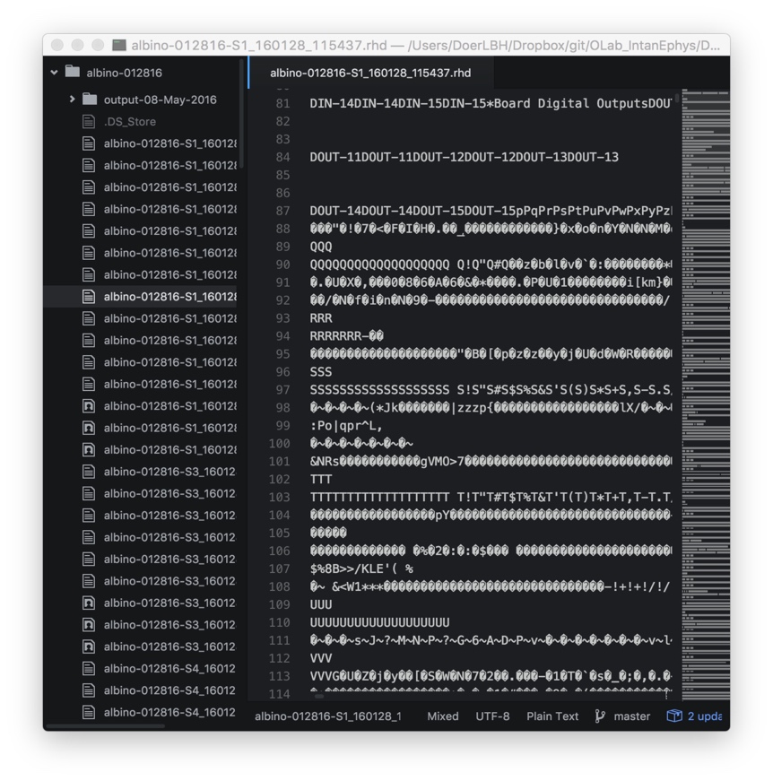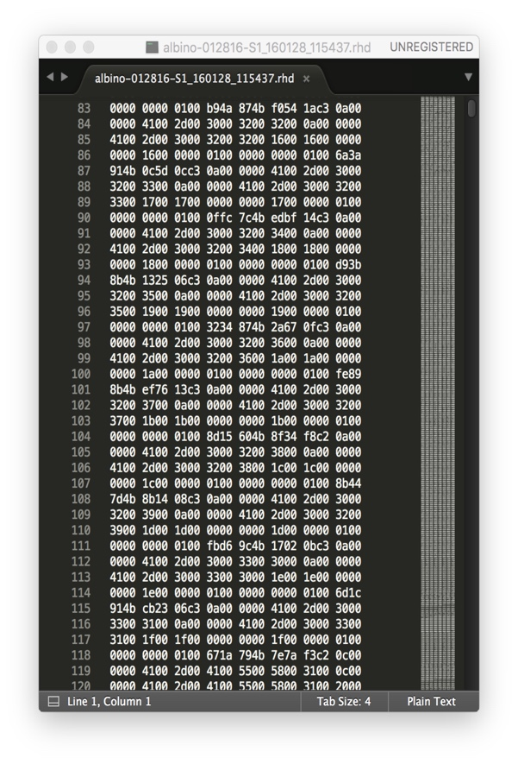

Figure . “.rhd” files are shown in binary (left) or hex (right), either unreadable

As shown, these “.rhd” files are not readable and has to be interpreted by official read_Intan_RHD2000_file.m and it generated a series of variables (Figure ):

>> whos

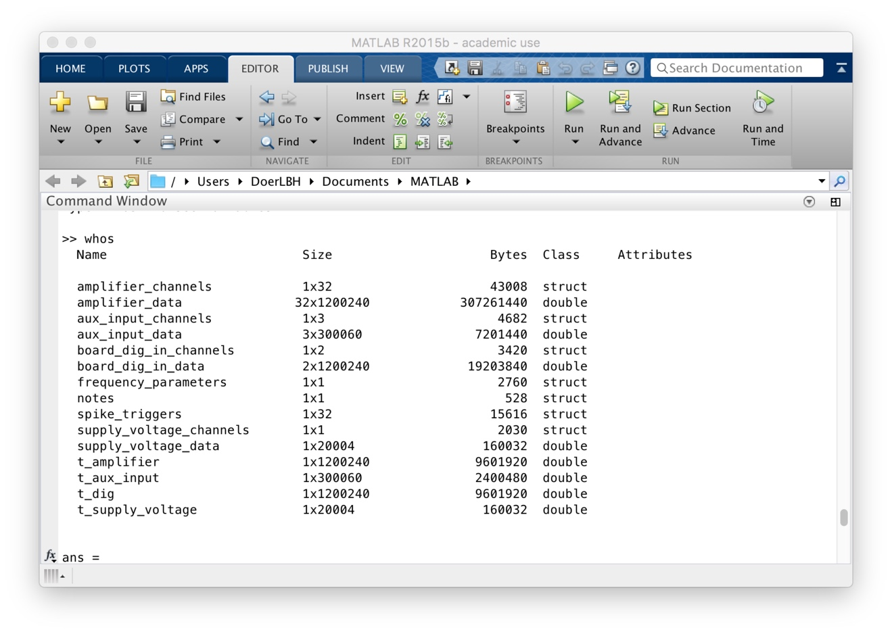

Figure . variables generated by read_Intan_RHD2000_file.m

**Step 3: analyze variables extracted from “.rhd” files**

Running backup_IntanEphysAnalysis_033016_Original.m, I encountered multiple issues, mostly due to MATLAB version discrepancy. And after debugging them, finally I made it run in backup_160407_IntanEphysAnalysis.m, whose console window is shown below in Figure .

This version of fixed analysis method, as implied in Figure of this instance, still encounters various problems analyzing different cases of “.rhd” files, including but not limited by “Index exceeds matrix dimensions”, “Reference to non-existent field 'Lrastercell'” etc..

This is due to the implicit nature of different cases of electrophysiology recording reflected by “.rhd”. And to ensure success, one needs to run separate steps and modify various locations of parameters in order to make it run smoothly by getting rid of the errors.

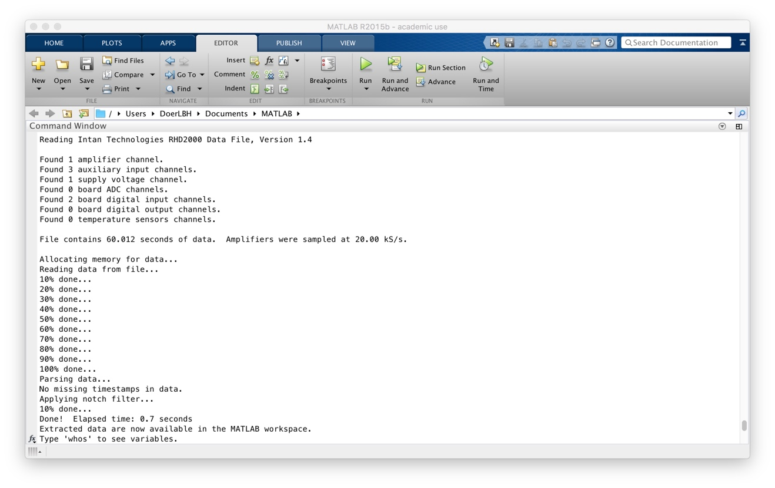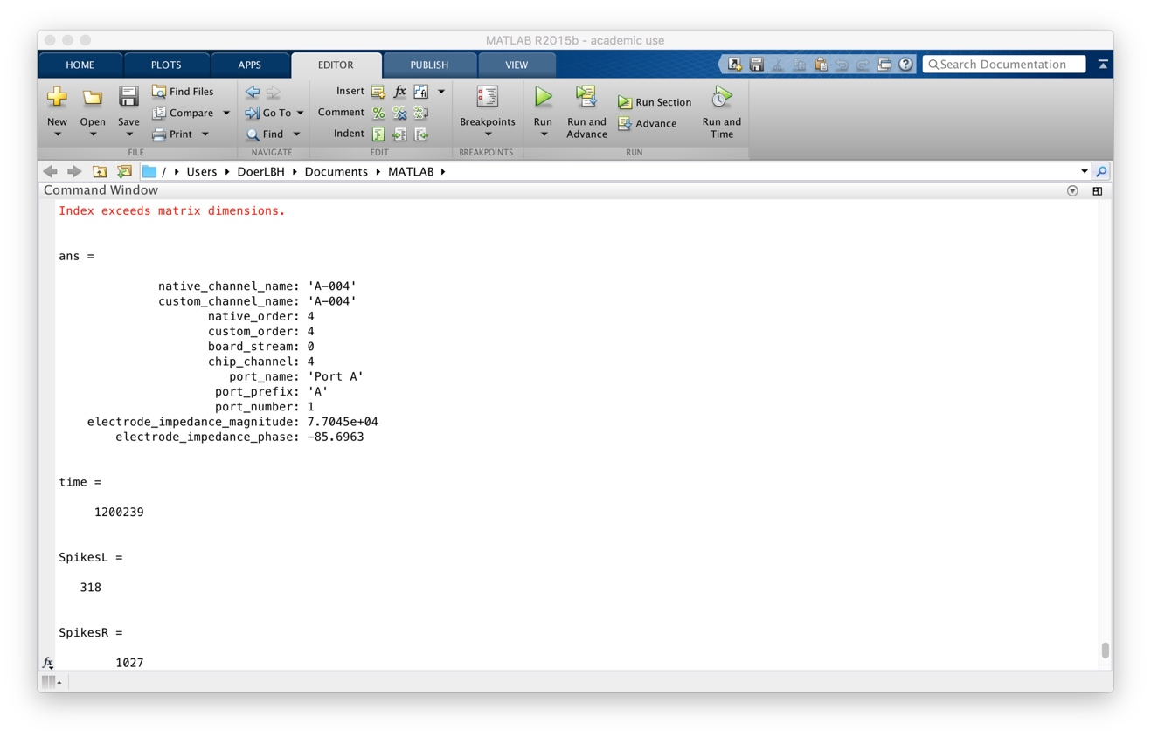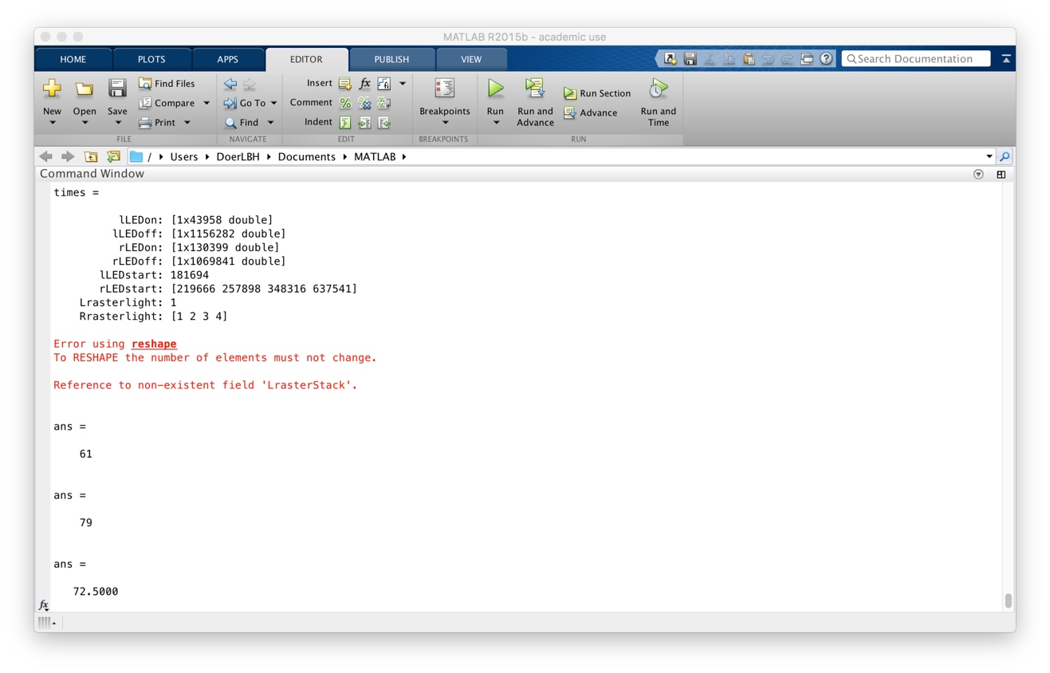

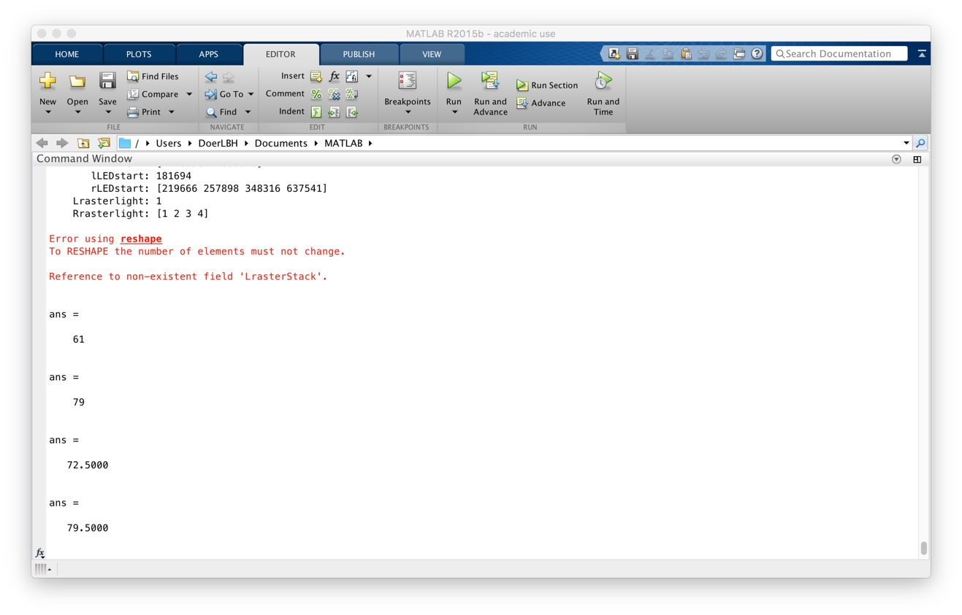

Figure . Console window of the traditional method on a test “*.rhd” file

**Step 4: export raster plots and recording spikes plot**

As shown below in Figure , there is the spikes plot and raster plots for left eye and right eye after multiple modifications in parameters in each cases. However, to be noted, this is only

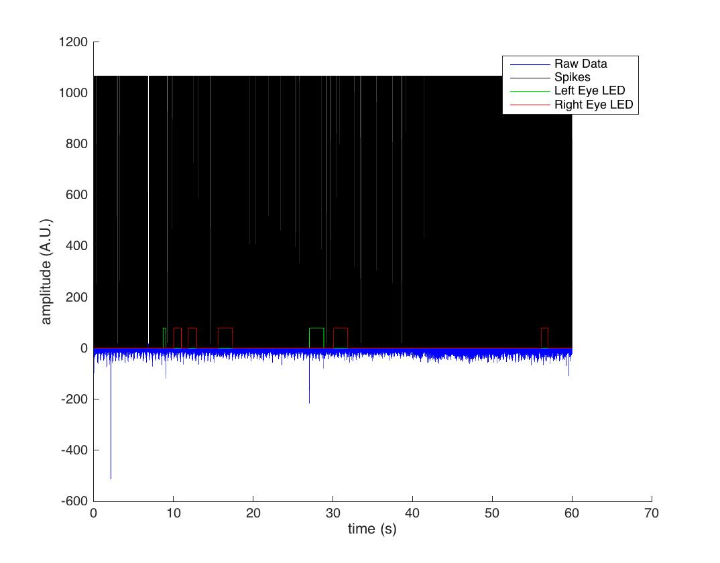

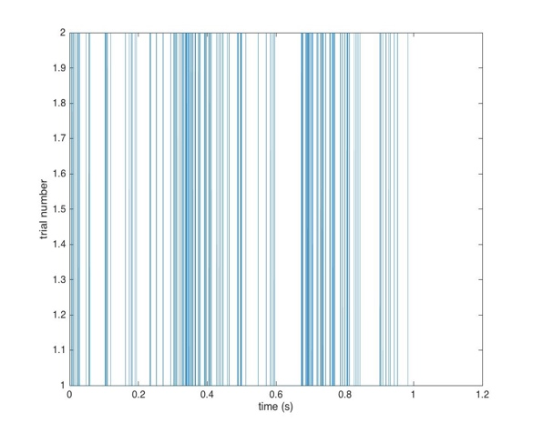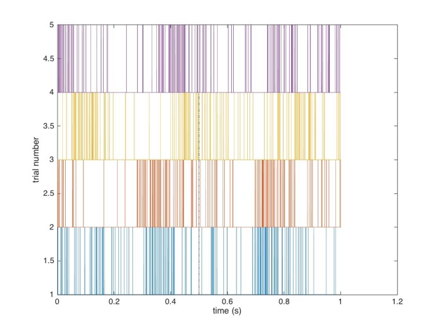

Figure . spikes plot and raster plots for left eye (left) and right eye (right)

**Issues to tackle:**

**(Efficiency & Validity)**

1. **Efficiency**

The traditional solution developed by Intan Technologies and Dr. Adrian Andelin consists of two parts: reading the binary datasets and plotting with analysis.

Take current data collected from lab in the past half year as an example:

011216 (ignored due to failed testing of Intan equipment)

albino-012816 129 cases

albino-020116 139 cases

MD-012516 62 cases

Normal-012616 111 cases

**In total 129 + 139 + 62 + 111 = 441 cases**

If one use this method, taking an average analyzing time of one instances for 40 minutes (for running the program, changing variables based on different properties of each case to make it work, exporting the images), he or she would be spending 441 * 40 minutes = 17,640 minutes = 294 hours = 12.25 days (for 24 hours) = 14.7 weeks (for 20 hours per week) = 147 days (2 hours per day). This is terrifying for a lab to analysis only four rats.

1. **Validity**

As shown in previous graphs and analysis

**Attempt 1: Mac Terminal Concatenation:**

**(failed)**

**Perhaps we can concatenate the “.rhd” files of the same recording instance into one single file.**

I tried below (Figure ), making the assumption that “.rhd” files are simply headless binary datasets that can be easily combined.

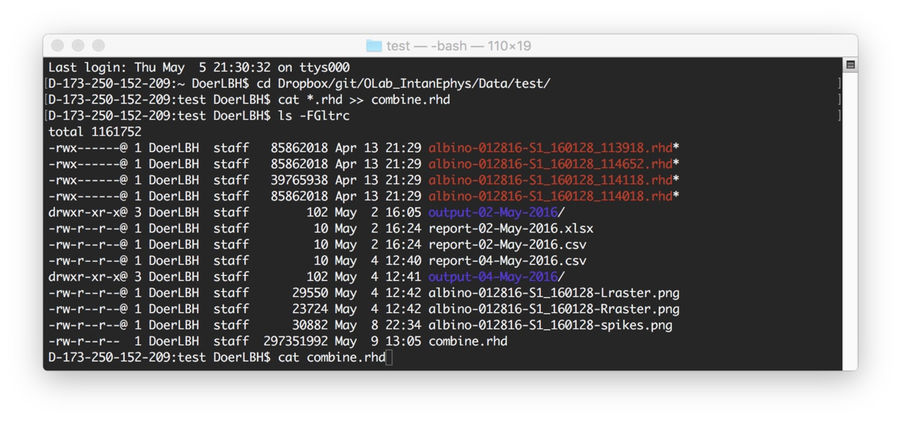

Figure . Mac terminal command to concatenate “.rhd” files

My assumption was wrong (Figure ), so we need to combine them later with MATLAB.

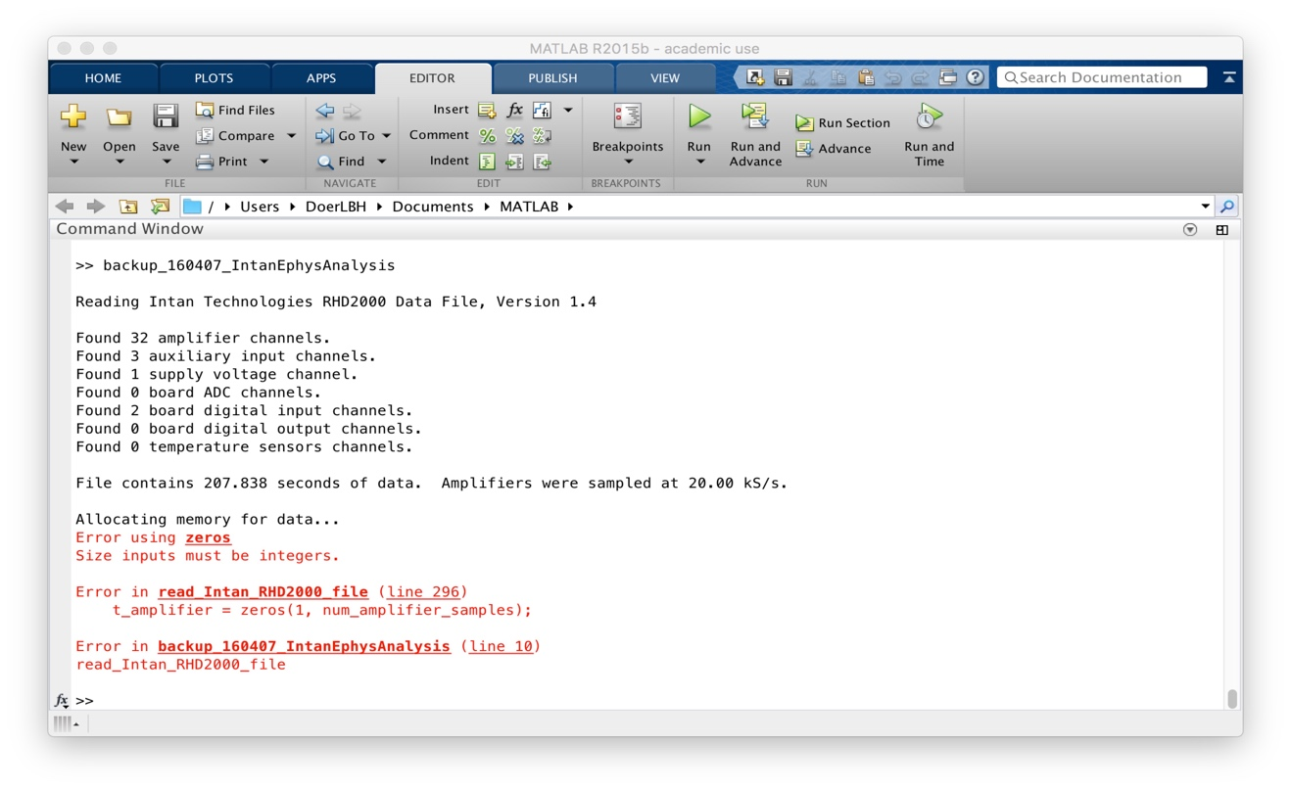

**Attempt 2: MATLAB Combination:**

**(success)**

I decided to use a different approach by having

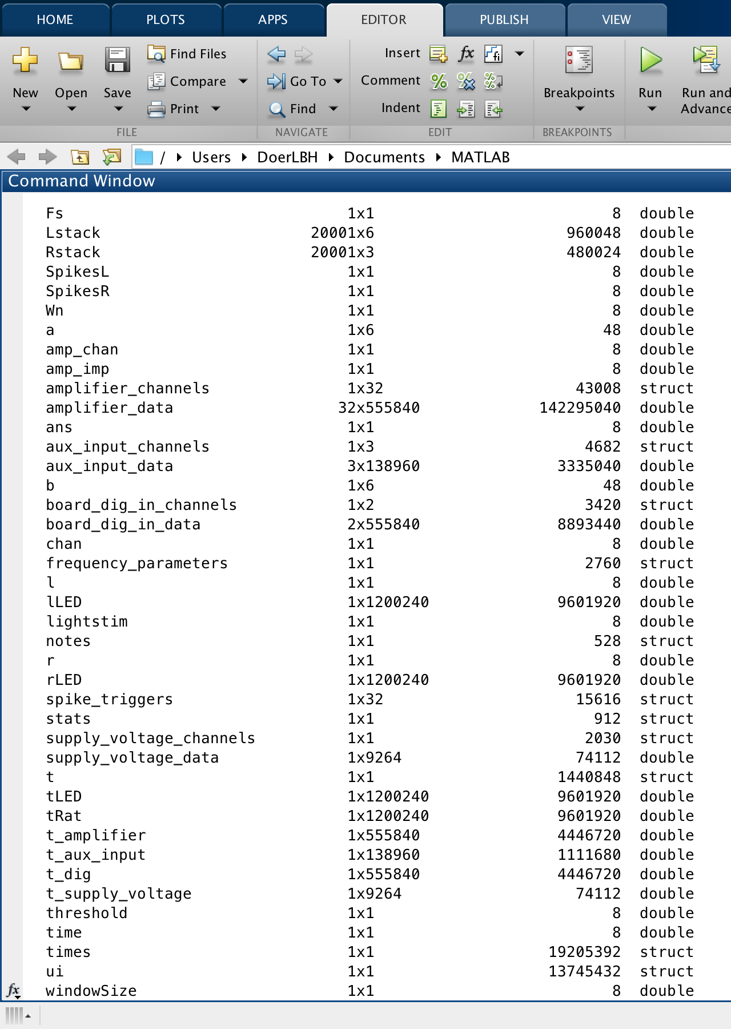

Fs

Lstack

Rstack

SpikesL

SpikesR

Wn

a

amp_chan

amp_imp

amplifier_channels

amplifier_data

ans

aux_input_channels

aux_input_data

b

board_dig_in_channels

board_dig_in_data

chan

frequency_parameters

l

lLED

lightstim

notes

r

rLED

spike_triggers

stats

supply_voltage_channels

supply_voltage_data

t

tLED

tRat

t_amplifier

t_aux_input

t_dig

t_supply_voltage

threshold

time

times

ui

windowSize

amplifier_channels 1x32 43008 struct

amplifier_data 32x555840 142295040 double

aux_input_channels 1x3 4682 struct

aux_input_data 3x138960 3335040 double

board_dig_in_channels 1x2 3420 struct

board_dig_in_data 2x555840 8893440 double

frequency_parameters 1x1 2760 struct

notes 1x1 528 struct

spike_triggers 1x32 15616 struct

supply_voltage_channels 1x1 2030 struct

supply_voltage_data 1x9264 74112 double

t_amplifier 1x555840 4446720 double

t_aux_input 1x138960 1111680 double

t_dig 1x555840 4446720 double

t_supply_voltage 1x9264 74112 double

amplifier_data 32x555840 142295040 double

aux_input_data 3x138960 3335040 double

board_dig_in_data 2x555840 8893440 double

supply_voltage_data 1x9264 74112 double

t_amplifier 1x555840 4446720 double

t_aux_input 1x138960 1111680 double

t_dig 1x555840 4446720 double

t_supply_voltage 1x9264 74112 double

/Users/DoerLBH/Dropbox/git/OLab_IntanEphys/Data/test

**Attempt 3: Excel Report Integration:**

**(success)**

Now having accomplished the combination, analysis and plotting, I want it to be able to export to Excel worksheet

Using my method, running the whole MATLAB analysis for all 441 cases can be accomplished within 10 minutes (normally 5 minutes is sufficient), with only one click and a wait for 10 minutes before viewing our products in specific folders. Comparing to the traditional method costing 17640 minutes, my method is 1764 times faster and saves almost 300 hours of work!

In addition, the



**Frequently Asked Questions (FAQ)**

**(for more, email** [**sunnylin@uw.edu**](mailto:sunnylin@uw.edu) **or google)**

1. **Why do I don’t have enough plots generated?**

This can be due to different reasons.

A common mistake is to put the parent folder instead of the innermost subfolder as your input. If so, the program can mistakenly assign wrong attributes. Be sure to choose the innermost subfolder to start with.

Another common reason can be a lack of LED input in the first place. This happens when both or one of the LED input is missing. Other possibilities will need more debugging.

1. **Why are there blue horizontal lines across the spike plots?**

This is due to the concatenation and it is normal. The program automatically add a datapoint of zero at zero second by default, thus creating the mysterious horizontal crossing.

1. **Why do plots popping up and vanishing? Am I doing something wrong?**

No, you are doing fine. The plots are designed to be popped when generated. But instead of letting hundred of plots flying out your screen, I closed them one by one in my codes.

1. **How do I know whether the analysis is finished so I can close the program?**

When you view the console and see “>>” in the front, you are all set to close.

1. **Where can I find all the plots and output?**

The log is located inside a folder name after “output” followed by date. The plots are located at the folder where the “.rhd” files are kept.

**Data Summary**

**(for 441 cases available now)**

1. **Excel report**
2. **Figures**
   1. albino-012816
   2. albino-020116
   3. MD-012516
   4. Normal-012616

**Code Summary:**

**(in order of importance from high to low)**

1. **fast_160504_IntanEphysAnalysis.m**

% Modified by Baihan Lin

% to analyze the extracted information from Intan Tech recording data

% Apr 2016

clear all; %Starting a new analysis so we want to eliminate all old variables

close all;

%% Begin with opening file to be analyzed

%

%First we import the data using:

%read_Intan_RHD2000_file = Opens the Matlab file browser UI to locate the

%file of interest. Afterward it reads header info and establishes basic

%variables from the .rhd file

%

% read_Intan_RHD2000_file

%

%From function info: % Reads Intan Technologies RHD2000 data file generated by evaluation board

% GUI. Data are parsed and placed into variables that appear in the base

% MATLAB workspace. Therefore, it is recommended to execute a 'clear'

% command before running this program to clear all other variables from the

% base workspace.

% read_Intan_RHD2000_file_combine

%

% Version 1.3, 10 December 2013

%

% Reads Intan Technologies RHD2000 data file generated by evaluation board

% GUI. Data are parsed and placed into variables that appear in the base

% MATLAB workspace. Therefore, it is recommended to execute a 'clear'

% command before running this program to clear all other variables from the

% base workspace.

%

% Example:

% >> clear

% >> read_Intan_RHD200_file

% >> whos

% >> amplifier_channels(1)

% >> plot(t_amplifier, amplifier_data(1,:))

% Here I change it from:

%[file, path, filterindex] = uigetfile('*.rhd', 'Select an RHD2000 Data File', 'MultiSelect', 'off');

% Read most recent file automatically.

%path = 'C:\Users\Reid\Documents\RHD2132\testing\';

%d = dir([path '*.rhd']);

%file = d(end).name;

% I decided to use automatic method for data collection:

prompt = 'What is your folder?: ';

disp('e.g. /Users/DoerLBH/Dropbox/git/OLab_IntanEphys/Data');

path = input(prompt,'s');

% /Users/DoerLBH/Dropbox/git/OLab_IntanEphys/Data/test

% So that I can specify a folder to access all data files.

%[status, list] = system('cd path');

[~,list] = system(['find ' path ' -type f -name "*.rhd"']);

system(['mkdir ' path '/output-' date]);

system(['cd ' path '/output-' date]);

diary(strcat(path, '/output-', date, '/report_', date, '.out'));

diary on;

disp(path);

disp(date);

% warning('off','MATLAB:xlswrite:AddSheet');

% xlsfile = strcat(path, '/report-', date, '.xlsx');

% mycell = {'Excel'};

% xlswrite(xlsfile,mycell);

% % rpt = {strcat('report-', date, ' by Baihan Lin')};

% % xlswrite(xlsfile, rpt(1),'Report','A1');

files = strsplit(list);

length(files);

for countfile = 1:length(files)

trials{countfile} = files{countfile}(1:end-11);

end

trials = unique(trials);

trials = trials(~cellfun('isempty',trials));

index = strfind(files, trials{1});

for trial = 1 : length(trials)

filename = trials{trial};

indexsep = strfind(filename,'/');

last = indexsep(end);

index = strfind(files, filename);

indexmat = cell2mat(index);

[~,first,~] = unique(indexmat, 'first');

fast_arrange_Intan_RHD(files{first(1)});

amp_data = amplifier_data;

disp(filename(last+1:end));

try

ai_data = aux_input_data;

catch exception

disp('bad_ai_intialization');

end

try

bdi_data = board_dig_in_data;

catch exception

disp('bad_bdi_initialization');

end

try

sv_data = supply_voltage_data;

catch exception

disp('bad_sv_initialization');

end

try

t_ai = t_aux_input;

catch exception

disp('bad_t_ai_initialzation');

end

try

t_d = t_dig;

catch exception

disp('bad_t_dig_initialization');

end

try

t_sv = t_supply_voltage;

catch exception

disp('bad_t_sv_initialization');

end

disp('---------------------');

disp('normal');

% catch exception

% disp('---------------------');

% disp(filename(last+1:end));

% disp('Fail_to_initialize')

% end

t_amp = t_amplifier;

if length(index) > 1

for ind = 2 : length(index)

if index{ind} == 1

fast_arrange_Intan_RHD(files{ind});

try

amp_data = [amp_data, amplifier_data];

ai_data = [ai_data, aux_input_data];

bdi_data = [bdi_data, board_dig_in_data];

sv_data = [sv_data, supply_voltage_data];

t_amp = [t_amp, t_amplifier];

t_ai = [t_ai,t_aux_input];

t_d = [t_d, t_dig];

t_sv = [t_sv, t_supply_voltage];

catch exception

disp('fail_to_reassign_1')

end

end

end

end

amplifier_data = amp_data;

t_amplifier = t_amp;

try

aux_input_data = ai_data;

board_dig_in_data = bdi_data;

supply_voltage_data = sv_data;

t_aux_input = t_ai;

t_dig = t_d;

t_supply_voltage = t_sv;

catch

disp('fail_to_reassign_2');

end

%check what variables have been imported, especially if youre unsure

%whether accessory amplifier channels were disabled or not during recording

%% Establishing some basic variables from values pulled in by above function

amp_chan = 1;

amp_imp = amplifier_channels(1).electrode_impedance_magnitude;

for chan = 1 : length(amplifier_channels)

if amplifier_channels(chan).electrode_impedance_magnitude < amp_imp

amp_chan = chan;

amp_imp = amplifier_channels(chan).electrode_impedance_magnitude;

end

end

% disp('amplifer information');

amplifier_channels(amp_chan);

%Channel data is being collected on (on

%preamplifier this would be 'A-004'

%Above command gives data output about the channel on which data is being

%collected

%% Variable name changes below to simplify:

try

tRat = t_amplifier; %time variable for ephys data

tLED = t_dig; %time variable for LED data

try

ui.ratData = amplifier_data(amp_chan,:);

catch exception

ui.ratData = amplifier_data(1,:);

end

lLED = board_dig_in_data(1,:);

rLED = board_dig_in_data(2,:);

catch

end

% %% Check variables look right-- plot should be identical to last one

% figure % for spike detection

% hold on

% plot(tRat, ui.ratData,'blue')

% plot(tLED,lLED,'red') %max makes red lines continue across top half of vertical axis

% plot(tLED,rLED,'green')

% xlabel 'time (s)'

% ylabel 'amplitude (A.U.)'

% legend('Raw Data', 'Left Eye LED','Right Eye LED')

%% filter data

Wn = 300/10000; % Normalized cutoff frequency

[b,a] = butter(5,Wn,'high');

try

ui.ratData = filtfilt(b,a,ui.ratData);

%% invert signal data for thresholding

ui.ratData = ui.ratData.*(-1);

catch

end

%% Setting threshold for spikes and finding light ON times

threshold = 25;

Fs = 20000; %amplifier_sample_rate

windowSize = Fs * 0.05; %creates our time interval by taking the 20k

% sampling rate at which the data was collected and converts it to

% timestamps collected every millisecond, in other words the value of

% windowSize is 1 ms.

% Finding all spikes in recording:

try

ui.spikes = diff(ui.ratData > threshold) > 0.1;

catch

end

%% Plot Again with spikes showing & correct time axis now:

try

time = length(tRat)-1;

fig1 = figure; % for spike detection

% figure('units','normalized','position',[0 0 1 1]);

% figure('Visible','off');

hold on;

plot(tRat(1:time), ui.ratData(1:time),'blue');

plot(tRat(1:time), ui.spikes*max(ui.ratData),'black');

plot(tLED(1:time),lLED(1:time)*80,'green'); %max makes red lines continue across top half of vertical axis

plot(tLED(1:time),rLED(1:time)*80,'red');

xlabel 'time (s)';

ylabel 'amplitude (A.U.)';

legend('Raw Data', 'Spikes', 'Left Eye LED','Right Eye LED');

title(strcat(filename(last+1:end), ' spikes plot'));

% set(fig1, 'Position', [100, 100, 1920, 1080]);

saveas(fig1, strcat(filename, '-spikes.png'),'png');

% print(fig1, strcat(filename, '-spikes'),'-dpng');

close(fig1);

catch

end

%% Count spikes during each LED stimulation

% try

% SpikesL = sum(ui.spikes.*lLED(1:end-1));

% SpikesR = sum(ui.spikes.*rLED(1:end-1));

% disp(SpikesL);

% disp(SpikesR);

% % disp(strcat('SpikeL = ', SpikesL));

% % disp(strcat('SpikeR = ', SpikesR));

% catch

% disp('SpikesL_N/A');

% disp('SpikesR_N/A');

% end

%% This creates a whole lot of extra light related variables, but unsure if they are actually useful

lightstim = 199; %change?

try

ui.leftLEDon = diff(lLED < -lightstim)>0.1;

ui.rightLEDon = diff(rLED < -lightstim)>0.1;

% times.leftLED = find(leftLED == 500);

% times.rightLED = find(rightLED == 500);

%rewrite:

times.lLEDon = find(lLED == 1);

% Gives all time points that left LED is on

%result is a vector 1 x 80299

times.lLEDoff = find(lLED == 0);

% Gives all time points that left LED is off

%result is a vector 1 x 1119941

times.rLEDon = find(rLED == 1);

times.rLEDoff = find(rLED == 0);

catch

end

% the above code will break out the time points when the LED is on for each

% side and when it is off. Next step:

% Need to ask it to count how many times ui.spikes takes place

% during each LEDon segment

try

if length(times.lLEDon) == 0 || length(times.rLEDon) == 0

disp('WARNING!_Failed_to_detect_LED!')

disp(filename);

disp('---------------------');

else

%% gets light "on" times into one array

times.lLEDstart = times.lLEDon(diff(times.lLEDon)>Fs*0.05);

%results in three specific time points for this LED

times.rLEDstart = times.rLEDon(diff(times.rLEDon)>Fs*0.05);

% this turns the times.xLEDon into a list of the points when the LED turned

% on ***Use this for making a raster plot****

%results in two specific time points for this LED

%% create raster plots-Left Stim

% Error: Subscript indices must either be real ve integers or

% logicals.

for l = 1:length(times.lLEDstart)

% collects window of data each time the light stimulus initiated

windowSize = round(Fs*0.5); % window size in samples

ui.Lrastercell{l} = ui.spikes(times.lLEDstart(l) - windowSize:times.lLEDstart(l) + windowSize);

end

%In original script, variable that's equivalent to 'times.lLEDon' is e.g.

% a 23x1 double that includes only the start times for light turning

% on. Maybe be better to use times.lLEDstart?

%times.lLedon in this script gives the chunks when led was on, aka a

%1x80299 double

t.Lraster = transpose((1:length(ui.Lrastercell{1}(:)))/Fs);

t.Lraster = repmat(t.Lraster,1,length(times.lLEDstart));

% creates time vector for raster

times.Lrasterlight = 1:(length(times.lLEDstart));

t.Lrasterlight = ones(1,(length(times.lLEDstart)))*windowSize/Fs;

% creates dashed line for indicating stim onset on raster plot

ui.Lraster = horzcat(ui.Lrastercell{:});

% concatenates cell array into a double

Lstack = repmat(1:length(times.lLEDstart),length(t.Lraster),1);

% creates transform for stacking windowed data for the raster plot

%% create raster plots-Right Stim

% Error: Subscript indices must either be real ve integers or

% logicals.

for r = 1:length(times.rLEDstart)

% collects window of data each time the light stimulus initiated

windowSize = round(Fs*0.5); % window size in samples

ui.Rrastercell{r} = ui.spikes(times.rLEDstart(r) - windowSize:times.rLEDstart(r) + windowSize);

end

t.Rraster = transpose((1:length(ui.Rrastercell{1}(:)))/Fs);

t.Rraster = repmat(t.Rraster,1,length(times.rLEDstart));

% creates time vector for raster

times.Rrasterlight = 1:(length(times.rLEDstart));

t.Rrasterlight = ones(1,(length(times.rLEDstart)))*windowSize/Fs;

% creates dashed line for indicating stim onset on raster plot

ui.Rraster = horzcat(ui.Rrastercell{:});

% concatenates cell array into a double

Rstack = repmat(1:length(times.rLEDstart),length(t.Rraster),1);

% creates transform for stacking windowed data for the raster plot

%% Before running next part, need to find how many times light goes on,

% do this by checking the variable "times.lLEDstart" and "times.rLEDstart".

% It will either show the exact values for the start times or will indicate

% how many different light on times there are, if trials exceeds ~5.

% disp('LED light information: ');

% times

LLEDtime = times.Lrasterlight(end);

RLEDtime = times.Rrasterlight(end);

disp(LLEDtime);

disp(RLEDtime);

%% this number needs to be input as last value in reshape function below:

ui.LrasterStack = reshape(ui.Lraster,20001,length(times.Lrasterlight));

ui.RrasterStack = reshape(ui.Rraster,20001,length(times.Rrasterlight));

%% Check plot to verify reshape has been applied appropriately to LEFT data:

fig2 = figure; % creates raster plot

% figure('units','normalized','position',[0 0 1 1]);

% figure('Visible','off');

plot(t.Lraster,ui.LrasterStack+Lstack-1);

hold on;

line([0.5 0.5], [0 length(times.Lrasterlight)], 'Color', 'k', 'LineWidth',2)

% plot(t.Lrasterlight,times.Lrasterlight,'-black', 'LineWidth',8);

hold off;

ylabel 'trial number';

xlabel 'time (s)';

xlim([0 1]);

title(strcat(filename(last+1:end), ' Lraster plot'));

saveas(fig2, strcat(filename, '-Lraster.png'),'png');

% print(fig2, strcat(filename, '-Lraster'),'-dpng');

close(fig2);

%% Check plot to verify reshape has been applied appropriately to RIGHT data:

fig3 = figure; % creates raster plot

% figure('units','normalized','position',[0 0 1 1]);

% figure('Visible','off');

plot(t.Rraster,ui.RrasterStack+Rstack-1);

hold on;

line([0.5 0.5], [0 length(times.Rrasterlight)], 'Color', 'k', 'LineWidth',2)

hold off;

ylabel 'trial number';

xlabel 'time (s)';

xlim([0 1]);

title(strcat(filename(last+1:end), ' Rraster plot'));

saveas(fig3, strcat(trial, '-Rraster.png'),'png');

% print(fig3, strcat(filename, '-Rraster'),'-dpng');

close(fig3);

%% Lastly, get spike averages for each eye

stats.spikes.Laveon = sum(sum(ui.LrasterStack(windowSize:end,:)))/length(times.lLEDstart);

% % calculates average number of spikes after light turned on

stats.spikes.Laveoff = sum(sum(ui.LrasterStack(1:windowSize,:)))/length(times.lLEDstart);

% % calculates average number of spikes preceding light onset

% disp('For left eye (L):');

% disp(strcat('spike average (on):', stats.spikes.Laveon));

% disp(strcat('spike average (off):', stats.spikes.Laveoff));

LSpikeOn = stats.spikes.Laveon;

LSpikeOff = stats.spikes.Laveoff;

disp(LSpikeOn);

disp(LSpikeOff);

%% Lastly, get spike avwerages for each eye

stats.spikes.Raveon = sum(sum(ui.RrasterStack(windowSize:end,:)))/length(times.rLEDstart);

% % calculates average number of spikes after light turned on

stats.spikes.Raveoff = sum(sum(ui.RrasterStack(1:windowSize,:)))/length(times.rLEDstart);

% % calculates average number of spikes preceding light onset

%

% disp('For right eye (R):');

% disp(strcat('spike average (on):', stats.spikes.Raveon));

% disp(strcat('spike average (off):', stats.spikes.Raveoff));

RSpikeOn = stats.spikes.Raveon;

RSpikeOff = stats.spikes.Raveoff;

disp(RSpikeOn);

disp(RSpikeOff);

% disp(strcat('Finished!!!', filename));

% disp(strcat(SpikesL, SpikesR, LLEDtime, RLEDtime, LSpikeOn, LSpikeOff, RSpikeOn, RSpikeOff));

disp('---------------------');

end

catch

end

%%

% clear all %Starting a new analysis so we want to eliminate all old variables

close all;

clearvars -except path list files trials trial index;

end

system(['cd ' path '/output-' date]);

diary off;

1. **fast_arrange_Intan_RHD.m**

% Modified by Baihan Lin

% to extract information from Intan Tech recording data

% Apr 2016

function fast_arrange_Intan_RHD(file)

% Built upon read_Intan_RHD2000_file

%

% Version 1.3, 10 December 2013

%

% Reads Intan Technologies RHD2000 data file generated by evaluation board

% GUI. Data are parsed and placed into variables that appear in the base

% MATLAB workspace. Therefore, it is recommended to execute a 'clear'

% command before running this program to clear all other variables from the

% base workspace.

%

tic;

fid = fopen(file, 'r');

s = dir(file);

filesize = s.bytes;

% Check 'magic number' at beginning of file to make sure this is an Intan

% Technologies RHD2000 data file.

magic_number = fread(fid, 1, 'uint32');

if magic_number ~= hex2dec('c6912702')

error('Unrecognized file type.');

end

% Read version number.

data_file_main_version_number = fread(fid, 1, 'int16');

data_file_secondary_version_number = fread(fid, 1, 'int16');

% fprintf(1, '\n');

% fprintf(1, 'Reading Intan Technologies RHD2000 Data File, Version %d.%d\n', ...

% data_file_main_version_number, data_file_secondary_version_number);

% fprintf(1, '\n');

% Read information of sampling rate and amplifier frequency settings.

sample_rate = fread(fid, 1, 'single');

dsp_enabled = fread(fid, 1, 'int16');

actual_dsp_cutoff_frequency = fread(fid, 1, 'single');

actual_lower_bandwidth = fread(fid, 1, 'single');

actual_upper_bandwidth = fread(fid, 1, 'single');

desired_dsp_cutoff_frequency = fread(fid, 1, 'single');

desired_lower_bandwidth = fread(fid, 1, 'single');

desired_upper_bandwidth = fread(fid, 1, 'single');

% This tells us if a software 50/60 Hz notch filter was enabled during

% the data acquisition.

notch_filter_mode = fread(fid, 1, 'int16');

notch_filter_frequency = 0;

if (notch_filter_mode == 1)

notch_filter_frequency = 50;

elseif (notch_filter_mode == 2)

notch_filter_frequency = 60;

end

desired_impedance_test_frequency = fread(fid, 1, 'single');

actual_impedance_test_frequency = fread(fid, 1, 'single');

% Place notes in data strucure

notes = struct( ...

'note1', fread_QString(fid), ...

'note2', fread_QString(fid), ...

'note3', fread_QString(fid) );

% If data file is from GUI v1.1 or later, see if temperature sensor data

% was saved.

num_temp_sensor_channels = 0;

if ((data_file_main_version_number == 1 && data_file_secondary_version_number >= 1) ...

|| (data_file_main_version_number > 1))

num_temp_sensor_channels = fread(fid, 1, 'int16');

end

% If data file is from GUI v1.3 or later, load eval board mode.

eval_board_mode = 0;

if ((data_file_main_version_number == 1 && data_file_secondary_version_number >= 3) ...

|| (data_file_main_version_number > 1))

eval_board_mode = fread(fid, 1, 'int16');

end

% Place frequency-related information in data structure.

frequency_parameters = struct( ...

'amplifier_sample_rate', sample_rate, ...

'aux_input_sample_rate', sample_rate / 4, ...

'supply_voltage_sample_rate', sample_rate / 60, ...

'board_adc_sample_rate', sample_rate, ...

'board_dig_in_sample_rate', sample_rate, ...

'desired_dsp_cutoff_frequency', desired_dsp_cutoff_frequency, ...

'actual_dsp_cutoff_frequency', actual_dsp_cutoff_frequency, ...

'dsp_enabled', dsp_enabled, ...

'desired_lower_bandwidth', desired_lower_bandwidth, ...

'actual_lower_bandwidth', actual_lower_bandwidth, ...

'desired_upper_bandwidth', desired_upper_bandwidth, ...

'actual_upper_bandwidth', actual_upper_bandwidth, ...

'notch_filter_frequency', notch_filter_frequency, ...

'desired_impedance_test_frequency', desired_impedance_test_frequency, ...

'actual_impedance_test_frequency', actual_impedance_test_frequency );

% Define data structure for spike trigger settings.

spike_trigger_struct = struct( ...

'voltage_trigger_mode', {}, ...

'voltage_threshold', {}, ...

'digital_trigger_channel', {}, ...

'digital_edge_polarity', {} );

new_trigger_channel = struct(spike_trigger_struct);

spike_triggers = struct(spike_trigger_struct);

% Define data structure for data channels.

channel_struct = struct( ...

'native_channel_name', {}, ...

'custom_channel_name', {}, ...

'native_order', {}, ...

'custom_order', {}, ...

'board_stream', {}, ...

'chip_channel', {}, ...

'port_name', {}, ...

'port_prefix', {}, ...

'port_number', {}, ...

'electrode_impedance_magnitude', {}, ...

'electrode_impedance_phase', {} );

new_channel = struct(channel_struct);

% Create structure arrays for each type of data channel.

amplifier_channels = struct(channel_struct);

aux_input_channels = struct(channel_struct);

supply_voltage_channels = struct(channel_struct);

board_adc_channels = struct(channel_struct);

board_dig_in_channels = struct(channel_struct);

board_dig_out_channels = struct(channel_struct);

amplifier_index = 1;

aux_input_index = 1;

supply_voltage_index = 1;

board_adc_index = 1;

board_dig_in_index = 1;

board_dig_out_index = 1;

% Read signal summary from data file header.

number_of_signal_groups = fread(fid, 1, 'int16');

for signal_group = 1:number_of_signal_groups

signal_group_name = fread_QString(fid);

signal_group_prefix = fread_QString(fid);

signal_group_enabled = fread(fid, 1, 'int16');

signal_group_num_channels = fread(fid, 1, 'int16');

signal_group_num_amp_channels = fread(fid, 1, 'int16');

if (signal_group_num_channels > 0 && signal_group_enabled > 0)

new_channel(1).port_name = signal_group_name;

new_channel(1).port_prefix = signal_group_prefix;

new_channel(1).port_number = signal_group;

for signal_channel = 1:signal_group_num_channels

new_channel(1).native_channel_name = fread_QString(fid);

new_channel(1).custom_channel_name = fread_QString(fid);

new_channel(1).native_order = fread(fid, 1, 'int16');

new_channel(1).custom_order = fread(fid, 1, 'int16');

signal_type = fread(fid, 1, 'int16');

channel_enabled = fread(fid, 1, 'int16');

new_channel(1).chip_channel = fread(fid, 1, 'int16');

new_channel(1).board_stream = fread(fid, 1, 'int16');

new_trigger_channel(1).voltage_trigger_mode = fread(fid, 1, 'int16');

new_trigger_channel(1).voltage_threshold = fread(fid, 1, 'int16');

new_trigger_channel(1).digital_trigger_channel = fread(fid, 1, 'int16');

new_trigger_channel(1).digital_edge_polarity = fread(fid, 1, 'int16');

new_channel(1).electrode_impedance_magnitude = fread(fid, 1, 'single');

new_channel(1).electrode_impedance_phase = fread(fid, 1, 'single');

if (channel_enabled)

switch (signal_type)

case 0

amplifier_channels(amplifier_index) = new_channel;

spike_triggers(amplifier_index) = new_trigger_channel;

amplifier_index = amplifier_index + 1;

case 1

aux_input_channels(aux_input_index) = new_channel;

aux_input_index = aux_input_index + 1;

case 2

supply_voltage_channels(supply_voltage_index) = new_channel;

supply_voltage_index = supply_voltage_index + 1;

case 3

board_adc_channels(board_adc_index) = new_channel;

board_adc_index = board_adc_index + 1;

case 4

board_dig_in_channels(board_dig_in_index) = new_channel;

board_dig_in_index = board_dig_in_index + 1;

case 5

board_dig_out_channels(board_dig_out_index) = new_channel;

board_dig_out_index = board_dig_out_index + 1;

otherwise

error('Unknown channel type');

end

end

end

end

end

% Summarize contents of data file.

num_amplifier_channels = amplifier_index - 1;

num_aux_input_channels = aux_input_index - 1;

num_supply_voltage_channels = supply_voltage_index - 1;

num_board_adc_channels = board_adc_index - 1;

num_board_dig_in_channels = board_dig_in_index - 1;

num_board_dig_out_channels = board_dig_out_index - 1;

% fprintf(1, 'Found %d amplifier channel%s.\n', ...

% num_amplifier_channels, plural(num_amplifier_channels));

% fprintf(1, 'Found %d auxiliary input channel%s.\n', ...

% num_aux_input_channels, plural(num_aux_input_channels));

% fprintf(1, 'Found %d supply voltage channel%s.\n', ...

% num_supply_voltage_channels, plural(num_supply_voltage_channels));

% fprintf(1, 'Found %d board ADC channel%s.\n', ...

% num_board_adc_channels, plural(num_board_adc_channels));

% fprintf(1, 'Found %d board digital input channel%s.\n', ...

% num_board_dig_in_channels, plural(num_board_dig_in_channels));

% fprintf(1, 'Found %d board digital output channel%s.\n', ...

% num_board_dig_out_channels, plural(num_board_dig_out_channels));

% fprintf(1, 'Found %d temperature sensors channel%s.\n', ...

% num_temp_sensor_channels, plural(num_temp_sensor_channels));

% fprintf(1, '\n');

% Determine how many samples the data file contains.

% Each data block contains 60 amplifier samples.

bytes_per_block = 60 * 4; % timestamp data

bytes_per_block = bytes_per_block + 60 * 2 * num_amplifier_channels;

% Auxiliary inputs are sampled 4x slower than amplifiers

bytes_per_block = bytes_per_block + 15 * 2 * num_aux_input_channels;

% Supply voltage is sampled 60x slower than amplifiers

bytes_per_block = bytes_per_block + 1 * 2 * num_supply_voltage_channels;

% Board analog inputs are sampled at same rate as amplifiers

bytes_per_block = bytes_per_block + 60 * 2 * num_board_adc_channels;

% Board digital inputs are sampled at same rate as amplifiers

if (num_board_dig_in_channels > 0)

bytes_per_block = bytes_per_block + 60 * 2;

end

% Board digital outputs are sampled at same rate as amplifiers

if (num_board_dig_out_channels > 0)

bytes_per_block = bytes_per_block + 60 * 2;

end

% Temp sensor is sampled 60x slower than amplifiers

if (num_temp_sensor_channels > 0)

bytes_per_block = bytes_per_block + 1 * 2 * num_temp_sensor_channels;

end

% How many data blocks remain in this file?

data_present = 0;

bytes_remaining = filesize - ftell(fid);

if (bytes_remaining > 0)

data_present = 1;

end

num_data_blocks = bytes_remaining / bytes_per_block;

num_amplifier_samples = 60 * num_data_blocks;

num_aux_input_samples = 15 * num_data_blocks;

num_supply_voltage_samples = 1 * num_data_blocks;

num_board_adc_samples = 60 * num_data_blocks;

num_board_dig_in_samples = 60 * num_data_blocks;

num_board_dig_out_samples = 60 * num_data_blocks;

record_time = num_amplifier_samples / sample_rate;

% if (data_present)

% fprintf(1, 'File contains %0.3f seconds of data. Amplifiers were sampled at %0.2f kS/s.\n', ...

% record_time, sample_rate / 1000);

% fprintf(1, '\n');

% else

% fprintf(1, 'Header file contains no data. Amplifiers were sampled at %0.2f kS/s.\n', ...

% sample_rate / 1000);

% fprintf(1, '\n');

% end

if (data_present)

% Pre-allocate memory for data.

% fprintf(1, 'Allocating memory for data...\n');

t_amplifier = zeros(1, num_amplifier_samples);

amplifier_data = zeros(num_amplifier_channels, num_amplifier_samples);

aux_input_data = zeros(num_aux_input_channels, num_aux_input_samples);

supply_voltage_data = zeros(num_supply_voltage_channels, num_supply_voltage_samples);

temp_sensor_data = zeros(num_temp_sensor_channels, num_supply_voltage_samples);

board_adc_data = zeros(num_board_adc_channels, num_board_adc_samples);

board_dig_in_data = zeros(num_board_dig_in_channels, num_board_dig_in_samples);

board_dig_in_raw = zeros(1, num_board_dig_in_samples);

board_dig_out_data = zeros(num_board_dig_out_channels, num_board_dig_out_samples);

board_dig_out_raw = zeros(1, num_board_dig_out_samples);

% Read sampled data from file.

% fprintf(1, 'Reading data from file...\n');

amplifier_index = 1;

aux_input_index = 1;

supply_voltage_index = 1;

board_adc_index = 1;

board_dig_in_index = 1;

board_dig_out_index = 1;

print_increment = 10;

percent_done = print_increment;

for i=1:num_data_blocks

% In version 1.2, we moved from saving timestamps as unsigned

% integeters to signed integers to accomidate negative (adjusted)

% timestamps for pretrigger data.

if ((data_file_main_version_number == 1 && data_file_secondary_version_number >= 2) ...

|| (data_file_main_version_number > 1))

t_amplifier(amplifier_index:(amplifier_index+59)) = fread(fid, 60, 'int32');

else

t_amplifier(amplifier_index:(amplifier_index+59)) = fread(fid, 60, 'uint32');

end

if (num_amplifier_channels > 0)

amplifier_data(:, amplifier_index:(amplifier_index+59)) = fread(fid, [60, num_amplifier_channels], 'uint16')';

end

if (num_aux_input_channels > 0)

aux_input_data(:, aux_input_index:(aux_input_index+14)) = fread(fid, [15, num_aux_input_channels], 'uint16')';

end

if (num_supply_voltage_channels > 0)

supply_voltage_data(:, supply_voltage_index) = fread(fid, [1, num_supply_voltage_channels], 'uint16')';

end

if (num_temp_sensor_channels > 0)

temp_sensor_data(:, supply_voltage_index) = fread(fid, [1, num_temp_sensor_channels], 'int16')';

end

if (num_board_adc_channels > 0)

board_adc_data(:, board_adc_index:(board_adc_index+59)) = fread(fid, [60, num_board_adc_channels], 'uint16')';

end

if (num_board_dig_in_channels > 0)

board_dig_in_raw(board_dig_in_index:(board_dig_in_index+59)) = fread(fid, 60, 'uint16');

end

if (num_board_dig_out_channels > 0)

board_dig_out_raw(board_dig_out_index:(board_dig_out_index+59)) = fread(fid, 60, 'uint16');

end

amplifier_index = amplifier_index + 60;

aux_input_index = aux_input_index + 15;

supply_voltage_index = supply_voltage_index + 1;

board_adc_index = board_adc_index + 60;

board_dig_in_index = board_dig_in_index + 60;

board_dig_out_index = board_dig_out_index + 60;

fraction_done = 100 * (i / num_data_blocks);

if (fraction_done >= percent_done)

% fprintf(1, '%d%% done...\n', percent_done);

percent_done = percent_done + print_increment;

end

end

% Make sure we have read exactly the right amount of data.

bytes_remaining = filesize - ftell(fid);

if (bytes_remaining ~= 0)

%error('Error: End of file not reached.');

end

end

% Close data file.

fclose(fid);

if (data_present)

% fprintf(1, 'Parsing data...\n');

% Extract digital input channels to separate variables.

for i=1:num_board_dig_in_channels

mask = 2^(board_dig_in_channels(i).native_order) * ones(size(board_dig_in_raw));

board_dig_in_data(i, :) = (bitand(board_dig_in_raw, mask) > 0);

end

for i=1:num_board_dig_out_channels

mask = 2^(board_dig_out_channels(i).native_order) * ones(size(board_dig_out_raw));

board_dig_out_data(i, :) = (bitand(board_dig_out_raw, mask) > 0);

end

% Scale voltage levels appropriately.

amplifier_data = 0.195 * (amplifier_data - 32768); % units = microvolts

aux_input_data = 37.4e-6 * aux_input_data; % units = volts

supply_voltage_data = 74.8e-6 * supply_voltage_data; % units = volts

if (eval_board_mode == 1)

board_adc_data = 152.59e-6 * (board_adc_data - 32768); % units = volts

else

board_adc_data = 50.354e-6 * board_adc_data; % units = volts

end

temp_sensor_data = temp_sensor_data / 100; % units = deg C

% Check for gaps in timestamps.

num_gaps = sum(diff(t_amplifier) ~= 1);

% if (num_gaps == 0)

% fprintf(1, 'No missing timestamps in data.\n');

% else

% fprintf(1, 'Warning: %d gaps in timestamp data found. Time scale will not be uniform!\n', ...

% num_gaps);

% end

% Scale time steps (units = seconds).

t_amplifier = t_amplifier / sample_rate;

t_aux_input = t_amplifier(1:4:end);

t_supply_voltage = t_amplifier(1:60:end);

t_board_adc = t_amplifier;

t_dig = t_amplifier;

t_temp_sensor = t_supply_voltage;

% If the software notch filter was selected during the recording, apply the

% same notch filter to amplifier data here.

if (notch_filter_frequency > 0)

% fprintf(1, 'Applying notch filter...\n');

print_increment = 10;

percent_done = print_increment;

for i=1:num_amplifier_channels

amplifier_data(i,:) = ...

notch_filter(amplifier_data(i,:), sample_rate, notch_filter_frequency, 10);

fraction_done = 100 * (i / num_amplifier_channels);

if (fraction_done >= percent_done)

% fprintf(1, '%d%% done...\n', percent_done);

percent_done = percent_done + print_increment;

end

end

end

end

% Move variables to base workspace.

move_to_base_workspace(notes);

move_to_base_workspace(frequency_parameters);

if (num_amplifier_channels > 0)

move_to_base_workspace(amplifier_channels);

if (data_present)

move_to_base_workspace(amplifier_data);

move_to_base_workspace(t_amplifier);

end

move_to_base_workspace(spike_triggers);

end

if (num_aux_input_channels > 0)

move_to_base_workspace(aux_input_channels);

if (data_present)

move_to_base_workspace(aux_input_data);

move_to_base_workspace(t_aux_input);

end

end

if (num_supply_voltage_channels > 0)

move_to_base_workspace(supply_voltage_channels);

if (data_present)

move_to_base_workspace(supply_voltage_data);

move_to_base_workspace(t_supply_voltage);

end

end

if (num_board_adc_channels > 0)

move_to_base_workspace(board_adc_channels);

if (data_present)

move_to_base_workspace(board_adc_data);

move_to_base_workspace(t_board_adc);

end

end

if (num_board_dig_in_channels > 0)

move_to_base_workspace(board_dig_in_channels);

if (data_present)

move_to_base_workspace(board_dig_in_data);

move_to_base_workspace(t_dig);

end

end

if (num_board_dig_out_channels > 0)

move_to_base_workspace(board_dig_out_channels);

if (data_present)

move_to_base_workspace(board_dig_out_data);

move_to_base_workspace(t_dig);

end

end

if (num_temp_sensor_channels > 0)

if (data_present)

move_to_base_workspace(temp_sensor_data);

move_to_base_workspace(t_temp_sensor);

end

end

% fprintf(1, 'Done! Elapsed time: %0.1f seconds\n', toc);

% if (data_present)

% fprintf(1, 'Extracted data are now available in the MATLAB workspace.\n');

% else

% fprintf(1, 'Extracted waveform information is now available in the MATLAB workspace.\n');

% end

% fprintf(1, 'Type ''whos'' to see variables.\n');

% fprintf(1, '\n');

return

function a = fread_QString(fid)

% a = read_QString(fid)

%

% Read Qt style QString. The first 32-bit unsigned number indicates

% the length of the string (in bytes). If this number equals 0xFFFFFFFF,

% the string is null.

a = '';

length = fread(fid, 1, 'uint32');

if length == hex2num('ffffffff')

return;

end

% convert length from bytes to 16-bit Unicode words

length = length / 2;

for i=1:length

a(i) = fread(fid, 1, 'uint16');

end

return

function s = plural(n)

% s = plural(n)

%

% Utility function to optionally plurailze words based on the value

% of n.

if (n == 1)

s = '';

else

s = 's';

end

return

function out = notch_filter(in, fSample, fNotch, Bandwidth)

% out = notch_filter(in, fSample, fNotch, Bandwidth)

%

% Implements a notch filter (e.g., for 50 or 60 Hz) on vector 'in'.

% fSample = sample rate of data (in Hz or Samples/sec)

% fNotch = filter notch frequency (in Hz)

% Bandwidth = notch 3-dB bandwidth (in Hz). A bandwidth of 10 Hz is

% recommended for 50 or 60 Hz notch filters; narrower bandwidths lead to

% poor time-domain properties with an extended ringing response to

% transient disturbances.

%

% Example: If neural data was sampled at 30 kSamples/sec

% and you wish to implement a 60 Hz notch filter:

%

% out = notch_filter(in, 30000, 60, 10);

tstep = 1/fSample;

Fc = fNotch*tstep;

L = length(in);

% Calculate IIR filter parameters

d = exp(-2*pi*(Bandwidth/2)*tstep);

b = (1 + d*d)*cos(2*pi*Fc);

a0 = 1;

a1 = -b;

a2 = d*d;

a = (1 + d*d)/2;

b0 = 1;

b1 = -2*cos(2*pi*Fc);

b2 = 1;

out = zeros(size(in));

out(1) = in(1);

out(2) = in(2);

% (If filtering a continuous data stream, change out(1) and out(2) to the

% previous final two values of out.)

% Run filter

for i=3:L

out(i) = (a*b2*in(i-2) + a*b1*in(i-1) + a*b0*in(i) - a2*out(i-2) - a1*out(i-1))/a0;

end

return

function move_to_base_workspace(variable)

% move_to_base_workspace(variable)

%

% Move variable from function workspace to base MATLAB workspace so

% user will have access to it after the program ends.

variable_name = inputname(1);

assignin('base', variable_name, variable);

return;

1. **final_160430_IntanEphysAnalysis.m**

% Modified by Baihan Lin

% to analyze the extracted information from Intan Tech recording data

% Apr 2016

clear all %Starting a new analysis so we want to eliminate all old variables

close all

%% Begin with opening file to be analyzed

%

%First we import the data using:

%read_Intan_RHD2000_file = Opens the Matlab file browser UI to locate the

%file of interest. Afterward it reads header info and establishes basic

%variables from the .rhd file

%

% read_Intan_RHD2000_file

%

%From function info: % Reads Intan Technologies RHD2000 data file generated by evaluation board

% GUI. Data are parsed and placed into variables that appear in the base

% MATLAB workspace. Therefore, it is recommended to execute a 'clear'

% command before running this program to clear all other variables from the

% base workspace.

% read_Intan_RHD2000_file_combine

%

% Version 1.3, 10 December 2013

%

% Reads Intan Technologies RHD2000 data file generated by evaluation board

% GUI. Data are parsed and placed into variables that appear in the base

% MATLAB workspace. Therefore, it is recommended to execute a 'clear'

% command before running this program to clear all other variables from the

% base workspace.

%

% Example:

% >> clear

% >> read_Intan_RHD200_file

% >> whos

% >> amplifier_channels(1)

% >> plot(t_amplifier, amplifier_data(1,:))

% Here I change it from:

%[file, path, filterindex] = uigetfile('*.rhd', 'Select an RHD2000 Data File', 'MultiSelect', 'off');

% Read most recent file automatically.

%path = 'C:\Users\Reid\Documents\RHD2132\testing\';

%d = dir([path '*.rhd']);

%file = d(end).name;

% I decided to use automatic method for data collection:

prompt = 'What is your folder?: ';

disp('e.g. /Users/DoerLBH/Dropbox/git/OLab_IntanEphys/Data');

path = input(prompt,'s');

% /Users/DoerLBH/Dropbox/git/OLab_IntanEphys/Data/test

% So that I can specify a folder to access all data files.

%[status, list] = system('cd path');

[~,list] = system(['find ' path ' -type f -name "*.rhd"']);

system(['mkdir ' path '/output-' date]);

system(['cd ' path '/output-' date]);

diary(strcat(path, '/output-', date, '/report_', date, '.out'));

diary on;

disp(path);

disp(date);

warning('off','MATLAB:xlswrite:AddSheet');

xlsfile = strcat(path, '/report-', date, '.xlsx');

mycell = {'Excel'};

xlswrite(xlsfile,mycell);

% rpt = {strcat('report-', date, ' by Baihan Lin')};

% xlswrite(xlsfile, rpt(1),'Report','A1');

files = strsplit(list);

length(files);

for countfile = 1:length(files)

trials{countfile} = files{countfile}(1:end-11);

end

trials = unique(trials);

trials = trials(~cellfun('isempty',trials));

index = strfind(files, trials{1});

for trial = 1 : length(trials)

filename = trials{trial};

index = strfind(files, filename);

indexmat = cell2mat(index);

[~,first,~] = unique(indexmat, 'first');

arrange_Intan_RHD(files{first(1)});

amp_data = amplifier_data;

try

ai_data = aux_input_data;

bdi_data = board_dig_in_data;

sv_data = supply_voltage_data;

t_ai = t_aux_input;

t_d = t_dig;

t_sv = t_supply_voltage;

catch exception

end

t_amp = t_amplifier;

if length(index) > 1

for ind = 2 : length(index)

if index{ind} == 1

arrange_Intan_RHD(files{ind});

try

amp_data = [amp_data, amplifier_data];

ai_data = [ai_data, aux_input_data];

bdi_data = [bdi_data, board_dig_in_data];

sv_data = [sv_data, supply_voltage_data];

t_amp = [t_amp, t_amplifier];

t_ai = [t_ai,t_aux_input];

t_d = [t_d, t_dig];

t_sv = [t_sv, t_supply_voltage];

catch exception

end

end

end

end

amplifier_data = amp_data;

t_amplifier = t_amp;

try

aux_input_data = ai_data;

board_dig_in_data = bdi_data;

supply_voltage_data = sv_data;

t_aux_input = t_ai;

t_dig = t_d;

t_supply_voltage = t_sv;

catch

end

%check what variables have been imported, especially if youre unsure

%whether accessory amplifier channels were disabled or not during recording

%% Establishing some basic variables from values pulled in by above function

amp_chan = 1;

amp_imp = amplifier_channels(1).electrode_impedance_magnitude;

for chan = 1 : length(amplifier_channels)

if amplifier_channels(chan).electrode_impedance_magnitude < amp_imp

amp_chan = chan;

amp_imp = amplifier_channels(chan).electrode_impedance_magnitude;

end

end

disp('amplifer information');

amplifier_channels(amp_chan)

%Channel data is being collected on (on

%preamplifier this would be 'A-004'

%Above command gives data output about the channel on which data is being

%collected

%% Variable name changes below to simplify:

try

tRat = t_amplifier; %time variable for ephys data

tLED = t_dig; %time variable for LED data

try

ui.ratData = amplifier_data(amp_chan,:);

catch exception

ui.ratData = amplifier_data(1,:);

end

lLED = board_dig_in_data(1,:);

rLED = board_dig_in_data(2,:);

catch

end

% %% Check variables look right-- plot should be identical to last one

% figure % for spike detection

% hold on

% plot(tRat, ui.ratData,'blue')

% plot(tLED,lLED,'red') %max makes red lines continue across top half of vertical axis

% plot(tLED,rLED,'green')

% xlabel 'time (s)'

% ylabel 'amplitude (A.U.)'

% legend('Raw Data', 'Left Eye LED','Right Eye LED')

%% filter data

Wn = 300/10000; % Normalized cutoff frequency

[b,a] = butter(5,Wn,'high');

try

ui.ratData = filtfilt(b,a,ui.ratData);

%% invert signal data for thresholding

ui.ratData = ui.ratData.*(-1);

catch

end

%% Setting threshold for spikes and finding light ON times

threshold = 25;

Fs = 20000; %amplifier_sample_rate

windowSize = Fs * 0.05; %creates our time interval by taking the 20k

% sampling rate at which the data was collected and converts it to

% timestamps collected every millisecond, in other words the value of

% windowSize is 1 ms.

% Finding all spikes in recording:

try

ui.spikes = diff(ui.ratData > threshold) > 0.1;

catch

end

%% Plot Again with spikes showing & correct time axis now:

try

time = length(tRat)-1;

fig1 = figure; % for spike detection

% figure('units','normalized','position',[0 0 1 1]);

% figure('Visible','off');

hold on

plot(tRat(1:time), ui.ratData(1:time),'blue');

plot(tRat(1:time), ui.spikes*max(ui.ratData),'black');

plot(tLED(1:time),lLED(1:time)*80,'green'); %max makes red lines continue across top half of vertical axis

plot(tLED(1:time),rLED(1:time)*80,'red');

xlabel 'time (s)';

ylabel 'amplitude (A.U.)';

legend('Raw Data', 'Spikes', 'Left Eye LED','Right Eye LED');

% set(fig1, 'Position', [100, 100, 1920, 1080]);

saveas(fig1, strcat(filename, '-spikes.png'),'png');

% print(fig1, strcat(filename, '-spikes'),'-dpng');

close(fig1);

catch

end

%% Count spikes during each LED stimulation

try

SpikesL = sum(ui.spikes.*lLED(1:end-1));

SpikesR = sum(ui.spikes.*rLED(1:end-1));

disp(strcat('spikeL = ', SpikesL));

disp(strcat('spikeR = ', SpikesR));

catch

end

%% This creates a whole lot of extra light related variables, but unsure if they are actually useful

lightstim = 199; %change?

try

ui.leftLEDon = diff(lLED < -lightstim)>0.1;

ui.rightLEDon = diff(rLED < -lightstim)>0.1;

% times.leftLED = find(leftLED == 500);

% times.rightLED = find(rightLED == 500);

%rewrite:

times.lLEDon = find(lLED == 1);

% Gives all time points that left LED is on

%result is a vector 1 x 80299

times.lLEDoff = find(lLED == 0);

% Gives all time points that left LED is off

%result is a vector 1 x 1119941

times.rLEDon = find(rLED == 1);

times.rLEDoff = find(rLED == 0);

catch

end

% the above code will break out the time points when the LED is on for each

% side and when it is off. Next step:

% Need to ask it to count how many times ui.spikes takes place

% during each LEDon segment

try

if length(times.lLEDon) == 0 || length(times.rLEDon) == 0

disp('WARNING! Failed to detect LED!')

disp(filename);

disp('---------------------');

else

%% gets light "on" times into one array

times.lLEDstart = times.lLEDon(diff(times.lLEDon)>Fs*0.05);

%results in three specific time points for this LED

times.rLEDstart = times.rLEDon(diff(times.rLEDon)>Fs*0.05);

% this turns the times.xLEDon into a list of the points when the LED turned

% on ***Use this for making a raster plot****

%results in two specific time points for this LED

%% create raster plots-Left Stim

% Error: Subscript indices must either be real ve integers or

% logicals.

for l = 1:length(times.lLEDstart)

% collects window of data each time the light stimulus initiated

windowSize = round(Fs*0.5); % window size in samples

ui.Lrastercell{l} = ui.spikes(times.lLEDstart(l) - windowSize:times.lLEDstart(l) + windowSize);

end

%In original script, variable that's equivalent to 'times.lLEDon' is e.g.

% a 23x1 double that includes only the start times for light turning

% on. Maybe be better to use times.lLEDstart?

%times.lLedon in this script gives the chunks when led was on, aka a

%1x80299 double

t.Lraster = transpose((1:length(ui.Lrastercell{1}(:)))/Fs);

t.Lraster = repmat(t.Lraster,1,length(times.lLEDstart));

% creates time vector for raster

times.Lrasterlight = 1:(length(times.lLEDstart));

t.Lrasterlight = ones(1,(length(times.lLEDstart)))*windowSize/Fs;

% creates dashed line for indicating stim onset on raster plot

ui.Lraster = horzcat(ui.Lrastercell{:});

% concatenates cell array into a double

Lstack = repmat(1:length(times.lLEDstart),length(t.Lraster),1);

% creates transform for stacking windowed data for the raster plot

%% create raster plots-Right Stim

% Error: Subscript indices must either be real ve integers or

% logicals.

for r = 1:length(times.rLEDstart)

% collects window of data each time the light stimulus initiated

windowSize = round(Fs*0.5); % window size in samples

ui.Rrastercell{r} = ui.spikes(times.rLEDstart(r) - windowSize:times.rLEDstart(r) + windowSize);

end

t.Rraster = transpose((1:length(ui.Rrastercell{1}(:)))/Fs);

t.Rraster = repmat(t.Rraster,1,length(times.rLEDstart));

% creates time vector for raster

times.Rrasterlight = 1:(length(times.rLEDstart));

t.Rrasterlight = ones(1,(length(times.rLEDstart)))*windowSize/Fs;

% creates dashed line for indicating stim onset on raster plot

ui.Rraster = horzcat(ui.Rrastercell{:});

% concatenates cell array into a double

Rstack = repmat(1:length(times.rLEDstart),length(t.Rraster),1);

% creates transform for stacking windowed data for the raster plot

%% Before running next part, need to find how many times light goes on,

% do this by checking the variable "times.lLEDstart" and "times.rLEDstart".

% It will either show the exact values for the start times or will indicate

% how many different light on times there are, if trials exceeds ~5.

disp('LED light information: ');

times

%% this number needs to be input as last value in reshape function below:

ui.LrasterStack = reshape(ui.Lraster,20001,length(times.Lrasterlight));

ui.RrasterStack = reshape(ui.Rraster,20001,length(times.Rrasterlight));

%% Check plot to verify reshape has been applied appropriately to LEFT data:

fig2 = figure % creates raster plot

% figure('units','normalized','position',[0 0 1 1]);

% figure('Visible','off');

plot(t.Lraster,ui.LrasterStack+Lstack-1);

hold on

line([0.5 0.5], [0 length(times.Lrasterlight)], 'Color', 'k', 'LineWidth',2)

% plot(t.Lrasterlight,times.Lrasterlight,'-black', 'LineWidth',8);

hold off

ylabel 'trial number';

xlabel 'time (s)';

xlim([0 1]);

saveas(fig2, strcat(filename, '-Lraster.png'),'png');

% print(fig2, strcat(filename, '-Lraster'),'-dpng');

close(fig2);

%% Check plot to verify reshape has been applied appropriately to RIGHT data:

fig3 = figure % creates raster plot

% figure('units','normalized','position',[0 0 1 1]);

% figure('Visible','off');

plot(t.Rraster,ui.RrasterStack+Rstack-1);

hold on

line([0.5 0.5], [0 length(times.Rrasterlight)], 'Color', 'k', 'LineWidth',2)

hold off

ylabel 'trial number';

xlabel 'time (s)';

xlim([0 1]);

saveas(fig3, strcat(filename, '-Rraster.png'),'png');

% print(fig3, strcat(filename, '-Rraster'),'-dpng');

close(fig3);

%% Lastly, get spike averages for each eye

stats.spikes.Laveon = sum(sum(ui.LrasterStack(windowSize:end,:)))/length(times.lLEDstart);

% % calculates average number of spikes after light turned on

stats.spikes.Laveoff = sum(sum(ui.LrasterStack(1:windowSize,:)))/length(times.lLEDstart);

% % calculates average number of spikes preceding light onset

disp('For left eye (L):');

disp(strcat('spike average (on):', stats.spikes.Laveon));

disp(strcat('spike average (off):', stats.spikes.Laveoff));

%% Lastly, get spike avwerages for each eye

stats.spikes.Raveon = sum(sum(ui.RrasterStack(windowSize:end,:)))/length(times.rLEDstart);

% % calculates average number of spikes after light turned on

stats.spikes.Raveoff = sum(sum(ui.RrasterStack(1:windowSize,:)))/length(times.rLEDstart);

% % calculates average number of spikes preceding light onset

disp('For right eye (R):');

disp(strcat('spike average (on):', stats.spikes.Raveon));

disp(strcat('spike average (off):', stats.spikes.Raveoff));

disp(strcat('Finished!!!', filename));

disp('--------------------------------');

end

catch

end

%%

% clear all %Starting a new analysis so we want to eliminate all old variables

close all

clearvars -except path list files trials trial index;

end

system(['cd ' path '/output-' date]);

diary off;

1. **arrange_Intan_RHD.m**

function arrange_Intan_RHD(file)

% Modified by Baihan Lin

% Apr 2016

% Built upon read_Intan_RHD2000_file

%

% Version 1.3, 10 December 2013

%

% Reads Intan Technologies RHD2000 data file generated by evaluation board

% GUI. Data are parsed and placed into variables that appear in the base

% MATLAB workspace. Therefore, it is recommended to execute a 'clear'

% command before running this program to clear all other variables from the

% base workspace.

%

tic;

fid = fopen(file, 'r');

s = dir(file);

filesize = s.bytes;

% Check 'magic number' at beginning of file to make sure this is an Intan

% Technologies RHD2000 data file.

magic_number = fread(fid, 1, 'uint32');

if magic_number ~= hex2dec('c6912702')

error('Unrecognized file type.');

end

% Read version number.

data_file_main_version_number = fread(fid, 1, 'int16');

data_file_secondary_version_number = fread(fid, 1, 'int16');

fprintf(1, '\n');

fprintf(1, 'Reading Intan Technologies RHD2000 Data File, Version %d.%d\n', ...

data_file_main_version_number, data_file_secondary_version_number);

fprintf(1, '\n');

% Read information of sampling rate and amplifier frequency settings.

sample_rate = fread(fid, 1, 'single');

dsp_enabled = fread(fid, 1, 'int16');

actual_dsp_cutoff_frequency = fread(fid, 1, 'single');

actual_lower_bandwidth = fread(fid, 1, 'single');

actual_upper_bandwidth = fread(fid, 1, 'single');

desired_dsp_cutoff_frequency = fread(fid, 1, 'single');

desired_lower_bandwidth = fread(fid, 1, 'single');

desired_upper_bandwidth = fread(fid, 1, 'single');

% This tells us if a software 50/60 Hz notch filter was enabled during

% the data acquisition.

notch_filter_mode = fread(fid, 1, 'int16');

notch_filter_frequency = 0;

if (notch_filter_mode == 1)

notch_filter_frequency = 50;

elseif (notch_filter_mode == 2)

notch_filter_frequency = 60;

end

desired_impedance_test_frequency = fread(fid, 1, 'single');

actual_impedance_test_frequency = fread(fid, 1, 'single');

% Place notes in data strucure

notes = struct( ...

'note1', fread_QString(fid), ...

'note2', fread_QString(fid), ...

'note3', fread_QString(fid) );

% If data file is from GUI v1.1 or later, see if temperature sensor data

% was saved.

num_temp_sensor_channels = 0;

if ((data_file_main_version_number == 1 && data_file_secondary_version_number >= 1) ...

|| (data_file_main_version_number > 1))

num_temp_sensor_channels = fread(fid, 1, 'int16');

end

% If data file is from GUI v1.3 or later, load eval board mode.

eval_board_mode = 0;

if ((data_file_main_version_number == 1 && data_file_secondary_version_number >= 3) ...

|| (data_file_main_version_number > 1))

eval_board_mode = fread(fid, 1, 'int16');

end

% Place frequency-related information in data structure.

frequency_parameters = struct( ...

'amplifier_sample_rate', sample_rate, ...

'aux_input_sample_rate', sample_rate / 4, ...

'supply_voltage_sample_rate', sample_rate / 60, ...

'board_adc_sample_rate', sample_rate, ...

'board_dig_in_sample_rate', sample_rate, ...

'desired_dsp_cutoff_frequency', desired_dsp_cutoff_frequency, ...

'actual_dsp_cutoff_frequency', actual_dsp_cutoff_frequency, ...

'dsp_enabled', dsp_enabled, ...

'desired_lower_bandwidth', desired_lower_bandwidth, ...

'actual_lower_bandwidth', actual_lower_bandwidth, ...

'desired_upper_bandwidth', desired_upper_bandwidth, ...

'actual_upper_bandwidth', actual_upper_bandwidth, ...

'notch_filter_frequency', notch_filter_frequency, ...

'desired_impedance_test_frequency', desired_impedance_test_frequency, ...

'actual_impedance_test_frequency', actual_impedance_test_frequency );

% Define data structure for spike trigger settings.

spike_trigger_struct = struct( ...

'voltage_trigger_mode', {}, ...

'voltage_threshold', {}, ...

'digital_trigger_channel', {}, ...

'digital_edge_polarity', {} );

new_trigger_channel = struct(spike_trigger_struct);

spike_triggers = struct(spike_trigger_struct);

% Define data structure for data channels.

channel_struct = struct( ...

'native_channel_name', {}, ...

'custom_channel_name', {}, ...

'native_order', {}, ...

'custom_order', {}, ...

'board_stream', {}, ...

'chip_channel', {}, ...

'port_name', {}, ...

'port_prefix', {}, ...

'port_number', {}, ...

'electrode_impedance_magnitude', {}, ...

'electrode_impedance_phase', {} );

new_channel = struct(channel_struct);

% Create structure arrays for each type of data channel.

amplifier_channels = struct(channel_struct);

aux_input_channels = struct(channel_struct);

supply_voltage_channels = struct(channel_struct);

board_adc_channels = struct(channel_struct);

board_dig_in_channels = struct(channel_struct);

board_dig_out_channels = struct(channel_struct);

amplifier_index = 1;

aux_input_index = 1;

supply_voltage_index = 1;

board_adc_index = 1;

board_dig_in_index = 1;

board_dig_out_index = 1;

% Read signal summary from data file header.

number_of_signal_groups = fread(fid, 1, 'int16');

for signal_group = 1:number_of_signal_groups

signal_group_name = fread_QString(fid);

signal_group_prefix = fread_QString(fid);

signal_group_enabled = fread(fid, 1, 'int16');

signal_group_num_channels = fread(fid, 1, 'int16');

signal_group_num_amp_channels = fread(fid, 1, 'int16');

if (signal_group_num_channels > 0 && signal_group_enabled > 0)

new_channel(1).port_name = signal_group_name;

new_channel(1).port_prefix = signal_group_prefix;

new_channel(1).port_number = signal_group;

for signal_channel = 1:signal_group_num_channels

new_channel(1).native_channel_name = fread_QString(fid);

new_channel(1).custom_channel_name = fread_QString(fid);

new_channel(1).native_order = fread(fid, 1, 'int16');

new_channel(1).custom_order = fread(fid, 1, 'int16');

signal_type = fread(fid, 1, 'int16');

channel_enabled = fread(fid, 1, 'int16');

new_channel(1).chip_channel = fread(fid, 1, 'int16');

new_channel(1).board_stream = fread(fid, 1, 'int16');

new_trigger_channel(1).voltage_trigger_mode = fread(fid, 1, 'int16');

new_trigger_channel(1).voltage_threshold = fread(fid, 1, 'int16');

new_trigger_channel(1).digital_trigger_channel = fread(fid, 1, 'int16');

new_trigger_channel(1).digital_edge_polarity = fread(fid, 1, 'int16');

new_channel(1).electrode_impedance_magnitude = fread(fid, 1, 'single');

new_channel(1).electrode_impedance_phase = fread(fid, 1, 'single');

if (channel_enabled)

switch (signal_type)

case 0

amplifier_channels(amplifier_index) = new_channel;

spike_triggers(amplifier_index) = new_trigger_channel;

amplifier_index = amplifier_index + 1;

case 1

aux_input_channels(aux_input_index) = new_channel;

aux_input_index = aux_input_index + 1;

case 2

supply_voltage_channels(supply_voltage_index) = new_channel;

supply_voltage_index = supply_voltage_index + 1;

case 3

board_adc_channels(board_adc_index) = new_channel;

board_adc_index = board_adc_index + 1;

case 4

board_dig_in_channels(board_dig_in_index) = new_channel;

board_dig_in_index = board_dig_in_index + 1;

case 5

board_dig_out_channels(board_dig_out_index) = new_channel;

board_dig_out_index = board_dig_out_index + 1;

otherwise

error('Unknown channel type');

end

end

end

end

end

% Summarize contents of data file.

num_amplifier_channels = amplifier_index - 1;

num_aux_input_channels = aux_input_index - 1;

num_supply_voltage_channels = supply_voltage_index - 1;

num_board_adc_channels = board_adc_index - 1;

num_board_dig_in_channels = board_dig_in_index - 1;

num_board_dig_out_channels = board_dig_out_index - 1;

fprintf(1, 'Found %d amplifier channel%s.\n', ...

num_amplifier_channels, plural(num_amplifier_channels));

fprintf(1, 'Found %d auxiliary input channel%s.\n', ...

num_aux_input_channels, plural(num_aux_input_channels));

fprintf(1, 'Found %d supply voltage channel%s.\n', ...

num_supply_voltage_channels, plural(num_supply_voltage_channels));

fprintf(1, 'Found %d board ADC channel%s.\n', ...

num_board_adc_channels, plural(num_board_adc_channels));

fprintf(1, 'Found %d board digital input channel%s.\n', ...

num_board_dig_in_channels, plural(num_board_dig_in_channels));

fprintf(1, 'Found %d board digital output channel%s.\n', ...

num_board_dig_out_channels, plural(num_board_dig_out_channels));

fprintf(1, 'Found %d temperature sensors channel%s.\n', ...

num_temp_sensor_channels, plural(num_temp_sensor_channels));

fprintf(1, '\n');

% Determine how many samples the data file contains.

% Each data block contains 60 amplifier samples.

bytes_per_block = 60 * 4; % timestamp data

bytes_per_block = bytes_per_block + 60 * 2 * num_amplifier_channels;

% Auxiliary inputs are sampled 4x slower than amplifiers

bytes_per_block = bytes_per_block + 15 * 2 * num_aux_input_channels;

% Supply voltage is sampled 60x slower than amplifiers

bytes_per_block = bytes_per_block + 1 * 2 * num_supply_voltage_channels;

% Board analog inputs are sampled at same rate as amplifiers

bytes_per_block = bytes_per_block + 60 * 2 * num_board_adc_channels;

% Board digital inputs are sampled at same rate as amplifiers

if (num_board_dig_in_channels > 0)

bytes_per_block = bytes_per_block + 60 * 2;

end

% Board digital outputs are sampled at same rate as amplifiers

if (num_board_dig_out_channels > 0)

bytes_per_block = bytes_per_block + 60 * 2;

end

% Temp sensor is sampled 60x slower than amplifiers

if (num_temp_sensor_channels > 0)

bytes_per_block = bytes_per_block + 1 * 2 * num_temp_sensor_channels;

end

% How many data blocks remain in this file?

data_present = 0;

bytes_remaining = filesize - ftell(fid);

if (bytes_remaining > 0)

data_present = 1;

end

num_data_blocks = bytes_remaining / bytes_per_block;

num_amplifier_samples = 60 * num_data_blocks;

num_aux_input_samples = 15 * num_data_blocks;

num_supply_voltage_samples = 1 * num_data_blocks;

num_board_adc_samples = 60 * num_data_blocks;

num_board_dig_in_samples = 60 * num_data_blocks;

num_board_dig_out_samples = 60 * num_data_blocks;

record_time = num_amplifier_samples / sample_rate;

if (data_present)

fprintf(1, 'File contains %0.3f seconds of data. Amplifiers were sampled at %0.2f kS/s.\n', ...

record_time, sample_rate / 1000);

fprintf(1, '\n');

else

fprintf(1, 'Header file contains no data. Amplifiers were sampled at %0.2f kS/s.\n', ...

sample_rate / 1000);

fprintf(1, '\n');

end

if (data_present)

% Pre-allocate memory for data.

fprintf(1, 'Allocating memory for data...\n');

t_amplifier = zeros(1, num_amplifier_samples);

amplifier_data = zeros(num_amplifier_channels, num_amplifier_samples);

aux_input_data = zeros(num_aux_input_channels, num_aux_input_samples);

supply_voltage_data = zeros(num_supply_voltage_channels, num_supply_voltage_samples);

temp_sensor_data = zeros(num_temp_sensor_channels, num_supply_voltage_samples);

board_adc_data = zeros(num_board_adc_channels, num_board_adc_samples);

board_dig_in_data = zeros(num_board_dig_in_channels, num_board_dig_in_samples);

board_dig_in_raw = zeros(1, num_board_dig_in_samples);

board_dig_out_data = zeros(num_board_dig_out_channels, num_board_dig_out_samples);

board_dig_out_raw = zeros(1, num_board_dig_out_samples);

% Read sampled data from file.

fprintf(1, 'Reading data from file...\n');

amplifier_index = 1;

aux_input_index = 1;

supply_voltage_index = 1;

board_adc_index = 1;

board_dig_in_index = 1;

board_dig_out_index = 1;

print_increment = 10;

percent_done = print_increment;

for i=1:num_data_blocks

% In version 1.2, we moved from saving timestamps as unsigned

% integeters to signed integers to accomidate negative (adjusted)

% timestamps for pretrigger data.

if ((data_file_main_version_number == 1 && data_file_secondary_version_number >= 2) ...

|| (data_file_main_version_number > 1))

t_amplifier(amplifier_index:(amplifier_index+59)) = fread(fid, 60, 'int32');

else

t_amplifier(amplifier_index:(amplifier_index+59)) = fread(fid, 60, 'uint32');

end

if (num_amplifier_channels > 0)

amplifier_data(:, amplifier_index:(amplifier_index+59)) = fread(fid, [60, num_amplifier_channels], 'uint16')';

end

if (num_aux_input_channels > 0)

aux_input_data(:, aux_input_index:(aux_input_index+14)) = fread(fid, [15, num_aux_input_channels], 'uint16')';

end

if (num_supply_voltage_channels > 0)

supply_voltage_data(:, supply_voltage_index) = fread(fid, [1, num_supply_voltage_channels], 'uint16')';

end

if (num_temp_sensor_channels > 0)

temp_sensor_data(:, supply_voltage_index) = fread(fid, [1, num_temp_sensor_channels], 'int16')';

end

if (num_board_adc_channels > 0)

board_adc_data(:, board_adc_index:(board_adc_index+59)) = fread(fid, [60, num_board_adc_channels], 'uint16')';

end

if (num_board_dig_in_channels > 0)

board_dig_in_raw(board_dig_in_index:(board_dig_in_index+59)) = fread(fid, 60, 'uint16');

end

if (num_board_dig_out_channels > 0)

board_dig_out_raw(board_dig_out_index:(board_dig_out_index+59)) = fread(fid, 60, 'uint16');

end

amplifier_index = amplifier_index + 60;

aux_input_index = aux_input_index + 15;

supply_voltage_index = supply_voltage_index + 1;

board_adc_index = board_adc_index + 60;

board_dig_in_index = board_dig_in_index + 60;

board_dig_out_index = board_dig_out_index + 60;

fraction_done = 100 * (i / num_data_blocks);

if (fraction_done >= percent_done)

fprintf(1, '%d%% done...\n', percent_done);

percent_done = percent_done + print_increment;

end

end

% Make sure we have read exactly the right amount of data.

bytes_remaining = filesize - ftell(fid);

if (bytes_remaining ~= 0)

%error('Error: End of file not reached.');

end

end

% Close data file.

fclose(fid);

if (data_present)

fprintf(1, 'Parsing data...\n');

% Extract digital input channels to separate variables.

for i=1:num_board_dig_in_channels

mask = 2^(board_dig_in_channels(i).native_order) * ones(size(board_dig_in_raw));

board_dig_in_data(i, :) = (bitand(board_dig_in_raw, mask) > 0);

end

for i=1:num_board_dig_out_channels

mask = 2^(board_dig_out_channels(i).native_order) * ones(size(board_dig_out_raw));

board_dig_out_data(i, :) = (bitand(board_dig_out_raw, mask) > 0);

end

% Scale voltage levels appropriately.

amplifier_data = 0.195 * (amplifier_data - 32768); % units = microvolts

aux_input_data = 37.4e-6 * aux_input_data; % units = volts

supply_voltage_data = 74.8e-6 * supply_voltage_data; % units = volts

if (eval_board_mode == 1)

board_adc_data = 152.59e-6 * (board_adc_data - 32768); % units = volts

else

board_adc_data = 50.354e-6 * board_adc_data; % units = volts

end

temp_sensor_data = temp_sensor_data / 100; % units = deg C

% Check for gaps in timestamps.

num_gaps = sum(diff(t_amplifier) ~= 1);

if (num_gaps == 0)

fprintf(1, 'No missing timestamps in data.\n');

else

fprintf(1, 'Warning: %d gaps in timestamp data found. Time scale will not be uniform!\n', ...

num_gaps);

end

% Scale time steps (units = seconds).

t_amplifier = t_amplifier / sample_rate;

t_aux_input = t_amplifier(1:4:end);

t_supply_voltage = t_amplifier(1:60:end);

t_board_adc = t_amplifier;

t_dig = t_amplifier;

t_temp_sensor = t_supply_voltage;

% If the software notch filter was selected during the recording, apply the

% same notch filter to amplifier data here.

if (notch_filter_frequency > 0)

fprintf(1, 'Applying notch filter...\n');

print_increment = 10;

percent_done = print_increment;

for i=1:num_amplifier_channels

amplifier_data(i,:) = ...

notch_filter(amplifier_data(i,:), sample_rate, notch_filter_frequency, 10);

fraction_done = 100 * (i / num_amplifier_channels);

if (fraction_done >= percent_done)

fprintf(1, '%d%% done...\n', percent_done);

percent_done = percent_done + print_increment;

end

end

end

end

% Move variables to base workspace.

move_to_base_workspace(notes);

move_to_base_workspace(frequency_parameters);

if (num_amplifier_channels > 0)

move_to_base_workspace(amplifier_channels);

if (data_present)

move_to_base_workspace(amplifier_data);

move_to_base_workspace(t_amplifier);

end

move_to_base_workspace(spike_triggers);

end

if (num_aux_input_channels > 0)

move_to_base_workspace(aux_input_channels);

if (data_present)

move_to_base_workspace(aux_input_data);

move_to_base_workspace(t_aux_input);

end

end

if (num_supply_voltage_channels > 0)

move_to_base_workspace(supply_voltage_channels);

if (data_present)

move_to_base_workspace(supply_voltage_data);

move_to_base_workspace(t_supply_voltage);

end

end

if (num_board_adc_channels > 0)

move_to_base_workspace(board_adc_channels);

if (data_present)

move_to_base_workspace(board_adc_data);

move_to_base_workspace(t_board_adc);

end

end

if (num_board_dig_in_channels > 0)

move_to_base_workspace(board_dig_in_channels);

if (data_present)

move_to_base_workspace(board_dig_in_data);

move_to_base_workspace(t_dig);

end

end

if (num_board_dig_out_channels > 0)

move_to_base_workspace(board_dig_out_channels);

if (data_present)

move_to_base_workspace(board_dig_out_data);

move_to_base_workspace(t_dig);

end

end

if (num_temp_sensor_channels > 0)

if (data_present)

move_to_base_workspace(temp_sensor_data);

move_to_base_workspace(t_temp_sensor);

end

end

fprintf(1, 'Done! Elapsed time: %0.1f seconds\n', toc);

if (data_present)

fprintf(1, 'Extracted data are now available in the MATLAB workspace.\n');

else

fprintf(1, 'Extracted waveform information is now available in the MATLAB workspace.\n');

end

fprintf(1, 'Type ''whos'' to see variables.\n');

fprintf(1, '\n');

return

function a = fread_QString(fid)

% a = read_QString(fid)

%

% Read Qt style QString. The first 32-bit unsigned number indicates

% the length of the string (in bytes). If this number equals 0xFFFFFFFF,

% the string is null.

a = '';

length = fread(fid, 1, 'uint32');

if length == hex2num('ffffffff')

return;

end

% convert length from bytes to 16-bit Unicode words

length = length / 2;

for i=1:length

a(i) = fread(fid, 1, 'uint16');

end

return

function s = plural(n)

% s = plural(n)

%

% Utility function to optionally plurailze words based on the value

% of n.

if (n == 1)

s = '';

else

s = 's';

end

return

function out = notch_filter(in, fSample, fNotch, Bandwidth)

% out = notch_filter(in, fSample, fNotch, Bandwidth)

%

% Implements a notch filter (e.g., for 50 or 60 Hz) on vector 'in'.

% fSample = sample rate of data (in Hz or Samples/sec)

% fNotch = filter notch frequency (in Hz)

% Bandwidth = notch 3-dB bandwidth (in Hz). A bandwidth of 10 Hz is

% recommended for 50 or 60 Hz notch filters; narrower bandwidths lead to

% poor time-domain properties with an extended ringing response to

% transient disturbances.

%

% Example: If neural data was sampled at 30 kSamples/sec

% and you wish to implement a 60 Hz notch filter:

%

% out = notch_filter(in, 30000, 60, 10);

tstep = 1/fSample;

Fc = fNotch*tstep;

L = length(in);

% Calculate IIR filter parameters

d = exp(-2*pi*(Bandwidth/2)*tstep);

b = (1 + d*d)*cos(2*pi*Fc);

a0 = 1;

a1 = -b;

a2 = d*d;

a = (1 + d*d)/2;

b0 = 1;

b1 = -2*cos(2*pi*Fc);

b2 = 1;

out = zeros(size(in));

out(1) = in(1);

out(2) = in(2);

% (If filtering a continuous data stream, change out(1) and out(2) to the

% previous final two values of out.)

% Run filter

for i=3:L

out(i) = (a*b2*in(i-2) + a*b1*in(i-1) + a*b0*in(i) - a2*out(i-2) - a1*out(i-1))/a0;

end

return

function move_to_base_workspace(variable)

% move_to_base_workspace(variable)

%

% Move variable from function workspace to base MATLAB workspace so

% user will have access to it after the program ends.

variable_name = inputname(1);

assignin('base', variable_name, variable);

return;

1. **success_160426_IntanEphysAnalysis.m**

% Modified by Baihan Lin

% to extract information from Intan Tech recording data

% Apr 2016

clear all %Starting a new analysis so we want to eliminate all old variables

close all

%% Begin with opening file to be analyzed

%

%First we import the data using:

%read_Intan_RHD2000_file = Opens the Matlab file browser UI to locate the

%file of interest. Afterward it reads header info and establishes basic

%variables from the .rhd file

%

% read_Intan_RHD2000_file

%

%From function info: % Reads Intan Technologies RHD2000 data file generated by evaluation board

% GUI. Data are parsed and placed into variables that appear in the base

% MATLAB workspace. Therefore, it is recommended to execute a 'clear'

% command before running this program to clear all other variables from the

% base workspace.

% Modified by Baihan Lin

% Apr 2016

% read_Intan_RHD2000_file_combine

%

% Version 1.3, 10 December 2013

%

% Reads Intan Technologies RHD2000 data file generated by evaluation board

% GUI. Data are parsed and placed into variables that appear in the base

% MATLAB workspace. Therefore, it is recommended to execute a 'clear'

% command before running this program to clear all other variables from the

% base workspace.

%

% Example:

% >> clear

% >> read_Intan_RHD200_file

% >> whos

% >> amplifier_channels(1)

% >> plot(t_amplifier, amplifier_data(1,:))

% Here I change it from:

%[file, path, filterindex] = uigetfile('*.rhd', 'Select an RHD2000 Data File', 'MultiSelect', 'off');

% Read most recent file automatically.

%path = 'C:\Users\Reid\Documents\RHD2132\testing\';

%d = dir([path '*.rhd']);

%file = d(end).name;

% I decided to use automatic method for data collection:

prompt = 'What is your folder?: ';

disp('e.g. /Users/DoerLBH/Dropbox/git/OLab_IntanEphys/Data');

path = input(prompt,'s');

% /Users/DoerLBH/Dropbox/git/OLab_IntanEphys/Data/test

% So that I can specify a folder to access all data files.

%[status, list] = system('cd path');

[~,list] = system(['find ' path ' -type f -name "*.rhd"']);

system(['mkdir output-' date]);

system(['cd output-' date]);

diary(strcat(path, 'report_', date, '.out'));

diary on;

disp(path);

disp(date);

files = strsplit(list);

length(files);

for countfile = 1:length(files)

trials{countfile} = files{countfile}(1:end-11);

end

trials = unique(trials);

trials = trials(~cellfun('isempty',trials));

index = strfind(files, trials{1});

for trial = 1 : length(trials)

filename = trials{trial};

index = strfind(files, filename);

indexmat = cell2mat(index);

[~,first,~] = unique(indexmat, 'first');

arrange_Intan_RHD(files{first(1)});

amp_data = amplifier_data;

try

ai_data = aux_input_data;

bdi_data = board_dig_in_data;

sv_data = supply_voltage_data;

t_ai = t_aux_input;

t_d = t_dig;

t_sv = t_supply_voltage;

catch exception

end

t_amp = t_amplifier;

if length(index) > 1

for ind = 2 : length(index)

if index{ind} == 1

arrange_Intan_RHD(files{ind});

try

amp_data = [amp_data, amplifier_data];

ai_data = [ai_data, aux_input_data];

bdi_data = [bdi_data, board_dig_in_data];

sv_data = [sv_data, supply_voltage_data];

t_amp = [t_amp, t_amplifier];

t_ai = [t_ai,t_aux_input];

t_d = [t_d, t_dig];

t_sv = [t_sv, t_supply_voltage];

catch exception

end

end

end

end

amplifier_data = amp_data;

t_amplifier = t_amp;

try

aux_input_data = ai_data;

board_dig_in_data = bdi_data;

supply_voltage_data = sv_data;

t_aux_input = t_ai;

t_dig = t_d;

t_supply_voltage = t_sv;

catch

end

%check what variables have been imported, especially if youre unsure

%whether accessory amplifier channels were disabled or not during recording

%% Establishing some basic variables from values pulled in by above function

amp_chan = 1;

amp_imp = amplifier_channels(1).electrode_impedance_magnitude;

for chan = 1 : length(amplifier_channels)

if amplifier_channels(chan).electrode_impedance_magnitude < amp_imp

amp_chan = chan;

amp_imp = amplifier_channels(chan).electrode_impedance_magnitude;

end

end

disp('amplifer information');

amplifier_channels(amp_chan)

%Channel data is being collected on (on

%preamplifier this would be 'A-004'

%Above command gives data output about the channel on which data is being

%collected

%% Variable name changes below to simplify:

try

tRat = t_amplifier; %time variable for ephys data

tLED = t_dig; %time variable for LED data

try

ui.ratData = amplifier_data(amp_chan,:);

catch exception

ui.ratData = amplifier_data(1,:);

end

lLED = board_dig_in_data(1,:);

rLED = board_dig_in_data(2,:);

catch

end

% %% Check variables look right-- plot should be identical to last one

% figure % for spike detection

% hold on

% plot(tRat, ui.ratData,'blue')

% plot(tLED,lLED,'red') %max makes red lines continue across top half of vertical axis

% plot(tLED,rLED,'green')

% xlabel 'time (s)'

% ylabel 'amplitude (A.U.)'

% legend('Raw Data', 'Left Eye LED','Right Eye LED')

%% filter data

Wn = 300/10000; % Normalized cutoff frequency

[b,a] = butter(5,Wn,'high');

try

ui.ratData = filtfilt(b,a,ui.ratData);

%% invert signal data for thresholding

ui.ratData = ui.ratData.*(-1);

catch

end

%% Setting threshold for spikes and finding light ON times

threshold = 25;

Fs = 20000; %amplifier_sample_rate

windowSize = Fs * 0.05; %creates our time interval by taking the 20k

% sampling rate at which the data was collected and converts it to

% timestamps collected every millisecond, in other words the value of

% windowSize is 1 ms.

% Finding all spikes in recording:

try

ui.spikes = diff(ui.ratData > threshold) > 0.1;

catch

end

%% Plot Again with spikes showing & correct time axis now:

try

time = length(tRat)-1;

fig1 = figure; % for spike detection

% figure('units','normalized','position',[0 0 1 1]);

% figure('Visible','off');

hold on

plot(tRat(1:time), ui.ratData(1:time),'blue');

plot(tRat(1:time), ui.spikes*max(ui.ratData),'black');

plot(tLED(1:time),lLED(1:time)*80,'green'); %max makes red lines continue across top half of vertical axis

plot(tLED(1:time),rLED(1:time)*80,'red');

xlabel 'time (s)';

ylabel 'amplitude (A.U.)';

legend('Raw Data', 'Spikes', 'Left Eye LED','Right Eye LED');

% set(fig1, 'Position', [100, 100, 1920, 1080]);

saveas(fig1, strcat(filename, '-spikes.png'),'png');

% print(fig1, strcat(filename, '-spikes'),'-dpng');

close(fig1);

catch

end

%% Count spikes during each LED stimulation

try

SpikesL = sum(ui.spikes.*lLED(1:end-1));

SpikesR = sum(ui.spikes.*rLED(1:end-1));

disp(strcat('spikeL = ', SpikesL));

disp(strcat('spikeR = ', SpikesR));

catch

end

%% This creates a whole lot of extra light related variables, but unsure if they are actually useful

lightstim = 199; %change?

try

ui.leftLEDon = diff(lLED < -lightstim)>0.1;

ui.rightLEDon = diff(rLED < -lightstim)>0.1;

% times.leftLED = find(leftLED == 500);

% times.rightLED = find(rightLED == 500);

%rewrite:

times.lLEDon = find(lLED == 1);

% Gives all time points that left LED is on

%result is a vector 1 x 80299

times.lLEDoff = find(lLED == 0);

% Gives all time points that left LED is off

%result is a vector 1 x 1119941

times.rLEDon = find(rLED == 1);

times.rLEDoff = find(rLED == 0);

catch

end

% the above code will break out the time points when the LED is on for each

% side and when it is off. Next step:

% Need to ask it to count how many times ui.spikes takes place

% during each LEDon segment

try

if length(times.lLEDon) == 0 || length(times.rLEDon) == 0

disp('WARNING! Failed to detect LED!')

disp(filename);

disp('---------------------');

else

%% gets light "on" times into one array

times.lLEDstart = times.lLEDon(diff(times.lLEDon)>Fs*0.05);

%results in three specific time points for this LED

times.rLEDstart = times.rLEDon(diff(times.rLEDon)>Fs*0.05);

% this turns the times.xLEDon into a list of the points when the LED turned

% on ***Use this for making a raster plot****

%results in two specific time points for this LED

%% create raster plots-Left Stim

% Error: Subscript indices must either be real ve integers or

% logicals.

for l = 1:length(times.lLEDstart)

% collects window of data each time the light stimulus initiated

windowSize = round(Fs*0.5); % window size in samples

ui.Lrastercell{l} = ui.spikes(times.lLEDstart(l) - windowSize:times.lLEDstart(l) + windowSize);

end

%In original script, variable that's equivalent to 'times.lLEDon' is e.g.

% a 23x1 double that includes only the start times for light turning

% on. Maybe be better to use times.lLEDstart?

%times.lLedon in this script gives the chunks when led was on, aka a

%1x80299 double

t.Lraster = transpose((1:length(ui.Lrastercell{1}(:)))/Fs);

t.Lraster = repmat(t.Lraster,1,length(times.lLEDstart));

% creates time vector for raster

times.Lrasterlight = 1:(length(times.lLEDstart));

t.Lrasterlight = ones(1,(length(times.lLEDstart)))*windowSize/Fs;

% creates dashed line for indicating stim onset on raster plot

ui.Lraster = horzcat(ui.Lrastercell{:});

% concatenates cell array into a double

Lstack = repmat(1:length(times.lLEDstart),length(t.Lraster),1);

% creates transform for stacking windowed data for the raster plot

%% create raster plots-Right Stim

% Error: Subscript indices must either be real ve integers or

% logicals.

for r = 1:length(times.rLEDstart)

% collects window of data each time the light stimulus initiated

windowSize = round(Fs*0.5); % window size in samples

ui.Rrastercell{r} = ui.spikes(times.rLEDstart(r) - windowSize:times.rLEDstart(r) + windowSize);

end

t.Rraster = transpose((1:length(ui.Rrastercell{1}(:)))/Fs);

t.Rraster = repmat(t.Rraster,1,length(times.rLEDstart));

% creates time vector for raster

times.Rrasterlight = 1:(length(times.rLEDstart));

t.Rrasterlight = ones(1,(length(times.rLEDstart)))*windowSize/Fs;

% creates dashed line for indicating stim onset on raster plot

ui.Rraster = horzcat(ui.Rrastercell{:});

% concatenates cell array into a double

Rstack = repmat(1:length(times.rLEDstart),length(t.Rraster),1);

% creates transform for stacking windowed data for the raster plot

%% Before running next part, need to find how many times light goes on,

% do this by checking the variable "times.lLEDstart" and "times.rLEDstart".

% It will either show the exact values for the start times or will indicate

% how many different light on times there are, if trials exceeds ~5.

disp('LED light information: ');

times

%% this number needs to be input as last value in reshape function below:

ui.LrasterStack = reshape(ui.Lraster,20001,length(times.Lrasterlight));

ui.RrasterStack = reshape(ui.Rraster,20001,length(times.Rrasterlight));

%% Check plot to verify reshape has been applied appropriately to LEFT data:

fig2 = figure % creates raster plot

% figure('units','normalized','position',[0 0 1 1]);

% figure('Visible','off');

plot(t.Lraster,ui.LrasterStack+Lstack-1);

hold on

line([0.5 0.5], [0 length(times.Lrasterlight)], 'Color', 'k', 'LineWidth',2)

% plot(t.Lrasterlight,times.Lrasterlight,'-black', 'LineWidth',8);

hold off

ylabel 'trial number';

xlabel 'time (s)';

xlim([0 1]);

saveas(fig2, strcat(filename, '-Lraster.png'),'png');

% print(fig2, strcat(filename, '-Lraster'),'-dpng');

close(fig2);

%% Check plot to verify reshape has been applied appropriately to RIGHT data:

fig3 = figure % creates raster plot

% figure('units','normalized','position',[0 0 1 1]);

% figure('Visible','off');

plot(t.Rraster,ui.RrasterStack+Rstack-1);

hold on

line([0.5 0.5], [0 length(times.Rrasterlight)], 'Color', 'k', 'LineWidth',2)

hold off

ylabel 'trial number';

xlabel 'time (s)';

xlim([0 1]);

saveas(fig3, strcat(filename, '-Rraster.png'),'png');

% print(fig3, strcat(filename, '-Rraster'),'-dpng');

close(fig3);

%% Lastly, get spike averages for each eye

stats.spikes.Laveon = sum(sum(ui.LrasterStack(windowSize:end,:)))/length(times.lLEDstart);

% % calculates average number of spikes after light turned on

stats.spikes.Laveoff = sum(sum(ui.LrasterStack(1:windowSize,:)))/length(times.lLEDstart);

% % calculates average number of spikes preceding light onset

disp('For left eye (L):');

disp(strcat('spike average (on):', stats.spikes.Laveon));

disp(strcat('spike average (off):', stats.spikes.Laveoff));

%% Lastly, get spike avwerages for each eye

stats.spikes.Raveon = sum(sum(ui.RrasterStack(windowSize:end,:)))/length(times.rLEDstart);

% % calculates average number of spikes after light turned on

stats.spikes.Raveoff = sum(sum(ui.RrasterStack(1:windowSize,:)))/length(times.rLEDstart);

% % calculates average number of spikes preceding light onset

disp('For right eye (R):');

disp(strcat('spike average (on):', stats.spikes.Raveon));

disp(strcat('spike average (off):', stats.spikes.Raveoff));

disp(strcat('Finished!!!', filename));

disp('--------------------------------');

end

catch

end

%%

% clear all %Starting a new analysis so we want to eliminate all old variables

close all

clearvars -except path list files trials trial index;

end

diary off;

1. **all_160421_IntanEphysAnalysis.m**

clear all %Starting a new analysis so we want to eliminate all old variables

close all

%% Begin with opening file to be analyzed

%

%First we import the data using:

%read_Intan_RHD2000_file = Opens the Matlab file browser UI to locate the

%file of interest. Afterward it reads header info and establishes basic

%variables from the .rhd file

%

% read_Intan_RHD2000_file

%

%From function info: % Reads Intan Technologies RHD2000 data file generated by evaluation board

% GUI. Data are parsed and placed into variables that appear in the base

% MATLAB workspace. Therefore, it is recommended to execute a 'clear'

% command before running this program to clear all other variables from the

% base workspace.

read_Intan_RHD_combine

% /Users/DoerLBH/Dropbox/git/OLab_IntanEphys/Data/test

%check what variables have been imported, especially if youre unsure

%whether accessory amplifier channels were disabled or not during recording

%% Establishing some basic variables from values pulled in by above function

amp_chan = 1;

amp_imp = amplifier_channels(1).electrode_impedance_magnitude

for chan = 1 : length(amplifier_channels)

if amplifier_channels(chan).electrode_impedance_magnitude < amp_imp

amp_chan = chan;

end

end

amplifier_channels(amp_chan) %Channel data is being collected on (on

%preamplifier this would be 'A-004'

%Above command gives data output about the channel on which data is being

%collected

%% Variable name changes below to simplify:

tRat = t_amplifier; %time variable for ephys data

tLED = t_dig; %time variable for LED data

ui.ratData = amplifier_data(amp_chan,:);

lLED = board_dig_in_data(1,:);

rLED = board_dig_in_data(2,:);

% %% Check variables look right-- plot should be identical to last one

% figure % for spike detection

% hold on

% plot(tRat, ui.ratData,'blue')

% plot(tLED,lLED,'red') %max makes red lines continue across top half of vertical axis

% plot(tLED,rLED,'green')

% xlabel 'time (s)'

% ylabel 'amplitude (A.U.)'

% legend('Raw Data', 'Left Eye LED','Right Eye LED')

%% filter data

Wn = 300/10000; % Normalized cutoff frequency

[b,a] = butter(5,Wn,'high');

ui.ratData = filtfilt(b,a,ui.ratData);

%% invert signal data for thresholding

ui.ratData = ui.ratData.*(-1);

%% Setting threshold for spikes and finding light ON times

threshold = 25;

Fs = 20000; %amplifier_sample_rate

windowSize = Fs * 0.05; %creates our time interval by taking the 20k

% sampling rate at which the data was collected and converts it to

% timestamps collected every millisecond, in other words the value of

% windowSize is 1 ms.

% Finding all spikes in recording:

ui.spikes = diff(ui.ratData > threshold) > 0.1;

%% Plot Again with spikes showing & correct time axis now:

time = length(tRat)-1;

figure % for spike detection

hold on

plot(tRat(1:time), ui.ratData(1:time),'blue')

plot(tRat(1:time), ui.spikes*max(ui.ratData),'black')

plot(tLED(1:time),lLED(1:time)*80,'green') %max makes red lines continue across top half of vertical axis

plot(tLED(1:time),rLED(1:time)*80,'red')

xlabel 'time (s)'

ylabel 'amplitude (A.U.)'

legend('Raw Data', 'Spikes', 'Left Eye LED','Right Eye LED')

%% Count spikes during each LED stimulation

SpikesL = sum(ui.spikes.*lLED(1:end-1))

SpikesR = sum(ui.spikes.*rLED(1:end-1))

%% This creates a whole lot of extra light related variables, but unsure if they are actually useful

lightstim = 199; %change?

ui.leftLEDon = diff(lLED < -lightstim)>0.1;

ui.rightLEDon = diff(rLED < -lightstim)>0.1;

% times.leftLED = find(leftLED == 500);

% times.rightLED = find(rightLED == 500);

%rewrite:

times.lLEDon = find(lLED == 1);

% Gives all time points that left LED is on

%result is a vector 1 x 80299

times.lLEDoff = find(lLED == 0);

% Gives all time points that left LED is off

%result is a vector 1 x 1119941

times.rLEDon = find(rLED == 1);

times.rLEDoff = find(rLED == 0);

% the above code will break out the time points when the LED is on for each

% side and when it is off. Next step:

% Need to ask it to count how many times ui.spikes takes place

% during each LEDon segment

%% gets light "on" times into one array

times.lLEDstart = times.lLEDon(diff(times.lLEDon)>Fs*0.05);

%results in three specific time points for this LED

times.rLEDstart = times.rLEDon(diff(times.rLEDon)>Fs*0.05);

% this turns the times.xLEDon into a list of the points when the LED turned

% on ***Use this for making a raster plot****

%results in two specific time points for this LED

%% create raster plots-Left Stim

% Error: Subscript indices must either be real ve integers or

% logicals.

for l = 1:length(times.lLEDstart)

% collects window of data each time the light stimulus initiated

windowSize = round(Fs*0.5); % window size in samples

ui.Lrastercell{l} = ui.spikes(times.lLEDstart(l) - windowSize:times.lLEDstart(l) + windowSize);

end

%In original script, variable that's equivalent to 'times.lLEDon' is e.g.

% a 23x1 double that includes only the start times for light turning

% on. Maybe be better to use times.lLEDstart?

%times.lLedon in this script gives the chunks when led was on, aka a

%1x80299 double

t.Lraster = transpose((1:length(ui.Lrastercell{1}(:)))/Fs);

t.Lraster = repmat(t.Lraster,1,length(times.lLEDstart));

% creates time vector for raster

times.Lrasterlight = 1:(length(times.lLEDstart));

t.Lrasterlight = ones(1,(length(times.lLEDstart)))*windowSize/Fs;

% creates dashed line for indicating stim onset on raster plot

ui.Lraster = horzcat(ui.Lrastercell{:});

% concatenates cell array into a double

Lstack = repmat(1:length(times.lLEDstart),length(t.Lraster),1);

% creates transform for stacking windowed data for the raster plot

%% create raster plots-Right Stim

% Error: Subscript indices must either be real ve integers or

% logicals.

for r = 1:length(times.rLEDstart)

% collects window of data each time the light stimulus initiated

windowSize = round(Fs*0.5); % window size in samples

ui.Rrastercell{r} = ui.spikes(times.rLEDstart(r) - windowSize:times.rLEDstart(r) + windowSize);

end

t.Rraster = transpose((1:length(ui.Rrastercell{1}(:)))/Fs);

t.Rraster = repmat(t.Rraster,1,length(times.rLEDstart));

% creates time vector for raster

times.Rrasterlight = 1:(length(times.rLEDstart));

t.Rrasterlight = ones(1,(length(times.rLEDstart)))*windowSize/Fs;

% creates dashed line for indicating stim onset on raster plot

ui.Rraster = horzcat(ui.Rrastercell{:});

% concatenates cell array into a double

Rstack = repmat(1:length(times.rLEDstart),length(t.Rraster),1);

% creates transform for stacking windowed data for the raster plot

%% Before running next part, need to find how many times light goes on,

% do this by checking the variable "times.lLEDstart" and "times.rLEDstart".

% It will either show the exact values for the start times or will indicate

% how many different light on times there are, if trials exceeds ~5.

times

%% this number needs to be input as last value in reshape function below:

ui.LrasterStack = reshape(ui.Lraster,20001,length(times.Lrasterlight));

ui.RrasterStack = reshape(ui.Rraster,20001,length(times.Rrasterlight));

%% Check plot to verify reshape has been applied appropriately to LEFT data:

figure % creates raster plot

plot(t.Lraster,ui.LrasterStack+Lstack-1);

hold on

line([0.5 0.5], [0 length(times.Lrasterlight)], 'Color', 'k', 'LineWidth',2)

% plot(t.Lrasterlight,times.Lrasterlight,'-black', 'LineWidth',8);

hold off

ylabel 'trial number';

xlabel 'time (s)';

xlim([0 1]);

%% Check plot to verify reshape has been applied appropriately to RIGHT data:

figure % creates raster plot

plot(t.Rraster,ui.RrasterStack+Rstack-1);

hold on

line([0.5 0.5], [0 length(times.Rrasterlight)], 'Color', 'k', 'LineWidth',2)

hold off

ylabel 'trial number';

xlabel 'time (s)';

xlim([0 1]);

%% Lastly, get spike averages for each eye

stats.spikes.Laveon = sum(sum(ui.LrasterStack(windowSize:end,:)))/length(times.lLEDstart);

% % calculates average number of spikes after light turned on

stats.spikes.Laveoff = sum(sum(ui.LrasterStack(1:windowSize,:)))/length(times.lLEDstart);

% % calculates average number of spikes preceding light onset

stats.spikes.Laveon

stats.spikes.Laveoff

%% Lastly, get spike avwerages for each eye

stats.spikes.Raveon = sum(sum(ui.RrasterStack(windowSize:end,:)))/length(times.rLEDstart);

% % calculates average number of spikes after light turned on

stats.spikes.Raveoff = sum(sum(ui.RrasterStack(1:windowSize,:)))/length(times.rLEDstart);

% % calculates average number of spikes preceding light onset

stats.spikes.Raveon

stats.spikes.Raveoff

1. **read_Intan_RHD_combine.m**

function read_Intan_RHD_combine

% Modified by Baihan Lin

% Apr 2016

% read_Intan_RHD2000_file_combine

%

% Version 1.3, 10 December 2013

%

% Reads Intan Technologies RHD2000 data file generated by evaluation board

% GUI. Data are parsed and placed into variables that appear in the base

% MATLAB workspace. Therefore, it is recommended to execute a 'clear'

% command before running this program to clear all other variables from the

% base workspace.

%

% Example:

% >> clear

% >> read_Intan_RHD200_file

% >> whos

% >> amplifier_channels(1)

% >> plot(t_amplifier, amplifier_data(1,:))

% Here I change it from:

%[file, path, filterindex] = uigetfile('*.rhd', 'Select an RHD2000 Data File', 'MultiSelect', 'off');

% Read most recent file automatically.

%path = 'C:\Users\Reid\Documents\RHD2132\testing\';

%d = dir([path '*.rhd']);

%file = d(end).name;

% I decided to use automatic method for data collection:

prompt = 'What is your folder?: ';

path = input(prompt,'s');

% So that I can specify a folder to access all data files.

%[status, list] = system('cd path');

[~,list] = system(['find ' path ' -type f -name "*.rhd"']);

files = strsplit(list);

length(files);

for countfile = 1:length(files)

trials{countfile} = files{countfile}(1:end-11);

end

trials = unique(trials);

trials = trials(~cellfun('isempty',trials));

index = strfind(files, trials{1});

for trial = 1 : length(trials)

index = strfind(files, trials{trial});

indexmat = cell2mat(index);

[~,first,~] = unique(indexmat, 'first');

arrange_Intan_RHD(files{first(trial)});

amp_data = amplifier_data;

ai_data = aux_input_data;

bdi_data = board_dig_in_data;

sv_data = supply_voltage_data;

t_amp = t_amplifier;

t_ai = t_aux_input;

t_d = t_dig;

t_sv = t_supply_voltage;

if length(index) > 1

for ind = 2 : length(index)

if index{ind} == 1

arrange_Intan_RHD(files{ind});

amp_data = [amp_data, amplifier_data];

ai_data = [ai_data, aux_input_data];

bdi_data = [bdi_data, board_dig_in_data];

sv_data = [sv_data, supply_voltage_data];

t_amp = [t_amp, t_amplifier];

t_ai = [t_ai,t_aux_input];

t_d = [t_d, t_dig];

t_sv = [t_sv, t_supply_voltage];

end

end

end

amplifier_data = amp_data;

aux_input_data = ai_data;

board_dig_in_data = bdi_data;

supply_voltage_data = sv_data;

t_amplifier = t_amp;

t_aux_input = t_ai;

t_dig = t_d;

t_supply_voltage = t_sv;

disp('----------------')

end

end

1. **backup_160407_IntanEphysAnalysis.m**

% Debugged and Modifidied by Baihan Lin, Olavarria Lab

% April 2016

%% Begin with opening file to be analyzed

clear all %Starting a new analysis so we want to eliminate all old variables

close all

%

%First we import the data using:

%read_Intan_RHD2000_file = Opens the Matlab file browser UI to locate the

%file of interest. Afterward it reads header info and establishes basic

%variables from the .rhd file

%

read_Intan_RHD2000_file

%

%From function info: % Reads Intan Technologies RHD2000 data file generated by evaluation board

% GUI. Data are parsed and placed into variables that appear in the base

% MATLAB workspace. Therefore, it is recommended to execute a 'clear'

% command before running this program to clear all other variables from the

% base workspace.

%check what variables have been imported, especially if youre unsure

%whether accessory amplifier channels were disabled or not during recording

%% Establishing some basic variables from values pulled in by above function

amplifier_channels(1) %Channel data is being collected on (on

%preamplifier this would be 'A-004'

%Above command gives data output about the channel on which data is being

%collected

%% Variable name changes below to simplify:

tRat = t_amplifier; %time variable for ephys data

tLED = t_dig; %time variable for LED data

ui.ratData = amplifier_data(1,:);

lLED = board_dig_in_data(1,:);

rLED = board_dig_in_data(2,:);

% %% Check variables look right-- plot should be identical to last one

% figure % for spike detection

% hold on

% plot(tRat, ui.ratData,'blue')

% plot(tLED,lLED,'red') %max makes red lines continue across top half of vertical axis

% plot(tLED,rLED,'green')

% xlabel 'time (s)'

% ylabel 'amplitude (A.U.)'

% legend('Raw Data', 'Left Eye LED','Right Eye LED')

%% filter data

Wn = 300/10000; % Normalized cutoff frequency

[b,a] = butter(5,Wn,'high');

ui.ratData = filtfilt(b,a,ui.ratData);

%% invert signal data for thresholding

ui.ratData = ui.ratData.*(-1);

%% Setting threshold for spikes and finding light ON times

threshold = 20;

Fs = 20000; %amplifier_sample_rate

windowSize = Fs * 0.05; %creates our time interval by taking the 20k

% sampling rate at which the data was collected and converts it to

% timestamps collected every millisecond, in other words the value of

% windowSize is 1 ms.

% Finding all spikes in recording:

ui.spikes = diff(ui.ratData > threshold) > 0.1;

%% Plot Again with spikes showing & correct time axis now:

time =length(tRat)-1

figure % for spike detection

hold on

plot(tRat(1:time), ui.ratData(1:time),'blue')

plot(tRat(1:time), ui.spikes*max(ui.ratData),'black')

plot(tLED(1:time),lLED(1:time)*80,'green') %max makes red lines continue across top half of vertical axis

plot(tLED(1:time),rLED(1:time)*80,'red')

xlabel 'time (s)'

ylabel 'amplitude (A.U.)'

legend('Raw Data', 'Spikes', 'Left Eye LED','Right Eye LED')

%% Count spikes during each LED stimulation

SpikesL = sum(ui.spikes.*lLED(1:end-1))

SpikesR = sum(ui.spikes.*rLED(1:end-1))

%% This creates a whole lot of extra light related variables, but unsure if they are actually useful

lightstim = 199; %change?

ui.leftLEDon = diff(lLED < -lightstim)>0.1;

ui.rightLEDon = diff(rLED < -lightstim)>0.1;

% times.leftLED = find(leftLED == 500);

% times.rightLED = find(rightLED == 500);

%rewrite:

times.lLEDon = find(lLED == 1);

% Gives all time points that left LED is on

%result is a vector 1 x 80299

times.lLEDoff = find(lLED == 0);

% Gives all time points that left LED is off

%result is a vector 1 x 1119941

times.rLEDon = find(rLED == 1);

times.rLEDoff = find(rLED == 0);

% the above code will break out the time points when the LED is on for each

% side and when it is off. Next step:

% Need to ask it to count how many times ui.spikes takes place

% during each LEDon segment

%% gets light "on" times into one array

times.lLEDstart = times.lLEDon(diff(times.lLEDon)>Fs*0.05);

%results in three specific time points for this LED

times.rLEDstart = times.rLEDon(diff(times.rLEDon)>Fs*0.05);

% this turns the times.xLEDon into a list of the points when the LED turned

% on ***Use this for making a raster plot****

%results in two specific time points for this LED

%% create raster plots-Left Stim

% Error: Subscript indices must either be real ve integers or

% logicals.

for l = 1:length(times.lLEDstart)

% collects window of data each time the light stimulus initiated

windowSize = round(Fs*0.5); % window size in samples

ui.Lrastercell{l} = ui.spikes(times.lLEDstart(l) - windowSize:times.lLEDstart(l) + windowSize);

end

%In original script, variable that's equivalent to 'times.lLEDon' is e.g.

% a 23x1 double that includes only the start times for light turning

% on. Maybe be better to use times.lLEDstart?

%times.lLedon in this script gives the chunks when led was on, aka a

%1x80299 double

t.Lraster = transpose((1:length(ui.Lrastercell{1}(:)))/Fs);

t.Lraster = repmat(t.Lraster,1,length(times.lLEDstart));

% creates time vector for raster

times.Lrasterlight = 1:(length(times.lLEDstart));

t.Lrasterlight = ones(1,(length(times.lLEDstart)))*windowSize/Fs;

% creates dashed line for indicating stim onset on raster plot

ui.Lraster = horzcat(ui.Lrastercell{:});

% concatenates cell array into a double

Lstack = repmat(1:length(times.lLEDstart),length(t.Lraster),1);

% creates transform for stacking windowed data for the raster plot

%% create raster plots-Right Stim

% Error: Subscript indices must either be real ve integers or

% logicals.

for r = 1:length(times.rLEDstart)

% collects window of data each time the light stimulus initiated

windowSize = round(Fs*0.5); % window size in samples

ui.Rrastercell{r} = ui.spikes(times.rLEDstart(r) - windowSize:times.rLEDstart(r) + windowSize);

end

t.Rraster = transpose((1:length(ui.Rrastercell{1}(:)))/Fs);

t.Rraster = repmat(t.Rraster,1,length(times.rLEDstart));

% creates time vector for raster

times.Rrasterlight = 1:(length(times.rLEDstart));

t.Rrasterlight = ones(1,(length(times.rLEDstart)))*windowSize/Fs;

% creates dashed line for indicating stim onset on raster plot

ui.Rraster = horzcat(ui.Rrastercell{:});

% concatenates cell array into a double

Rstack = repmat(1:length(times.rLEDstart),length(t.Rraster),1);

% creates transform for stacking windowed data for the raster plot

%% Before running next part, need to find how many times light goes on,

% do this by checking the variable "times.lLEDstart" and "times.rLEDstart".

% It will either show the exact values for the start times or will indicate

% how many different light on times there are, if trials exceeds ~5.

times

%% this number needs to be input as last value in reshape function below:

ui.LrasterStack = reshape(ui.Lraster,20001,5);

ui.RrasterStack = reshape(ui.Rraster,20001,9);

%% Check plot to verify reshape has been applied appropriately to LEFT data:

figure % creates raster plot

plot(t.Lraster,ui.LrasterStack+Lstack);

hold on

plot(t.Lrasterlight,times.Lrasterlight,'-.black');

hold off

ylabel 'trial number'

xlabel 'time (s)'

%% Check plot to verify reshape has been applied appropriately to RIGHT data:

figure % creates raster plot

plot(t.Rraster,ui.RrasterStack+Rstack);

hold on

plot(t.Rrasterlight,times.Rrasterlight,'-.black');

hold off

ylabel 'trial number'

xlabel 'time (s)'

%% Lastly, get spike averages for each eye

stats.spikes.Laveon = sum(sum(ui.LrasterStack(windowSize:end,:)))/length(times.lLEDstart);

% % calculates average number of spikes after light turned on

stats.spikes.Laveoff = sum(sum(ui.LrasterStack(1:windowSize,:)))/length(times.lLEDstart);

% % calculates average number of spikes preceding light onset

stats.spikes.Laveon

stats.spikes.Laveoff

%% Lastly, get spike avwerages for each eye

stats.spikes.Raveon = sum(sum(ui.RrasterStack(windowSize:end,:)))/length(times.rLEDstart);

% % calculates average number of spikes after light turned on

stats.spikes.Raveoff = sum(sum(ui.RrasterStack(1:windowSize,:)))/length(times.rLEDstart);

% % calculates average number of spikes preceding light onset

stats.spikes.Raveon

stats.spikes.Raveoff

1. **backup_IntanEphysAnalysis_033016_Original.m**

%% Begin with opening file to be analyzed

clear all %Starting a new analysis so we want to eliminate all old variables

close all

%

%First we import the data using:

%read_Intan_RHD2000_file = Opens the Matlab file browser UI to locate the

%file of interest. Afterward it reads header info and establishes basic

%variables from the .rhd file

%

read_Intan_RHD2000_file

%

%From function info: % Reads Intan Technologies RHD2000 data file generated by evaluation board

% GUI. Data are parsed and placed into variables that appear in the base

% MATLAB workspace. Therefore, it is recommended to execute a 'clear'

% command before running this program to clear all other variables from the

% base workspace.

%check what variables have been imported, especially if youre unsure

%whether accessory amplifier channels were disabled or not during recording

%% Establishing some basic variables from values pulled in by above function

amplifier_channels(1) %Channel data is being collected on (on

%preamplifier this would be 'A-004'

%Above command gives data output about the channel on which data is being

%collected

%% Variable name changes below to simplify:

tRat = t_amplifier; %time variable for ephys data

tLED = t_dig; %time variable for LED data

ui.ratData = amplifier_data(1,:);

lLED = board_dig_in_data(1,:);

rLED = board_dig_in_data(2,:);

% %% Check variables look right-- plot should be identical to last one

% figure % for spike detection

% hold on

% plot(tRat, ui.ratData,'blue')

% plot(tLED,lLED,'red') %max makes red lines continue across top half of vertical axis

% plot(tLED,rLED,'green')

% xlabel 'time (s)'

% ylabel 'amplitude (A.U.)'

% legend('Raw Data', 'Left Eye LED','Right Eye LED')

%% filter data

Wn = 300/10000; % Normalized cutoff frequency

[b,a] = butter(5,Wn,'high');

ui.ratData = filtfilt(b,a,ui.ratData);

%% invert signal data for thresholding

ui.ratData = ui.ratData.*(-1);

%% Setting threshold for spikes and finding light ON times

threshold = 20;

Fs = 20000; %amplifier_sample_rate

windowSize = Fs * 0.05; %creates our time interval by taking the 20k

% sampling rate at which the data was collected and converts it to

% timestamps collected every millisecond, in other words the value of

% windowSize is 1 ms.

% Finding all spikes in recording:

ui.spikes = diff(ui.ratData > threshold) > 0.1;

%% Plot Again with spikes showing & correct time axis now:

t=length(tRat)-1

figure % for spike detection

hold on

plot(tRat(1:t), ui.ratData(1:t),'blue')

plot(tRat(1:t), ui.spikes*max(ui.ratData),'black')

plot(tLED(1:t),lLED(1:t)*80,'green') %max makes red lines continue across top half of vertical axis

plot(tLED(1:t),rLED(1:t)*80,'red')

xlabel 'time (s)'

ylabel 'amplitude (A.U.)'

legend('Raw Data', 'Spikes', 'Left Eye LED','Right Eye LED')

%% Count spikes during each LED stimulation

SpikesL = sum(ui.spikes.*lLED(1:end-1))

SpikesR = sum(ui.spikes.*rLED(1:end-1))

%% This creates a whole lot of extra light related variables, but unsure if they are actually useful

lightstim = 199; %change?

ui.leftLEDon = diff(lLED < -lightstim)>0.1;

ui.rightLEDon = diff(rLED < -lightstim)>0.1;

% times.leftLED = find(leftLED == 500);

% times.rightLED = find(rightLED == 500);

%rewrite:

times.lLEDon = find(lLED == 1);

% Gives all time points that left LED is on

%result is a vector 1 x 80299

times.lLEDoff = find(lLED == 0);

% Gives all time points that left LED is off

%result is a vector 1 x 1119941

times.rLEDon = find(rLED == 1);

times.rLEDoff = find(rLED == 0);

% the above code will break out the time points when the LED is on for each

% side and when it is off. Next step:

% Need to ask it to count how many times ui.spikes takes place

% during each LEDon segment

%% gets light "on" times into one array

times.lLEDstart = times.lLEDon(diff(times.lLEDon)>Fs*0.05);

%results in three specific time points for this LED

times.rLEDstart = times.rLEDon(diff(times.rLEDon)>Fs*0.05);

% this turns the times.xLEDon into a list of the points when the LED turned

% on ***Use this for making a raster plot****

%results in two specific time points for this LED

%% create raster plots-Left Stim

% Error: Subscript indices must either be real ve integers or

% logicals.

for l = 1:length(times.lLEDstart)

% collects window of data each time the light stimulus initiated

windowSize = round(Fs*0.5); % window size in samples

ui.Lrastercell{l} = ui.spikes(times.lLEDstart(l) - windowSize:times.lLEDstart(l) + windowSize);

end

%In original script, variable that's equivalent to 'times.lLEDon' is e.g.

% a 23x1 double that includes only the start times for light turning

% on. Maybe be better to use times.lLEDstart?

%times.lLedon in this script gives the chunks when led was on, aka a

%1x80299 double

t.Lraster = transpose((1:length(ui.Lrastercell{1}(:)))/Fs);

t.Lraster = repmat(t.Lraster,1,length(times.lLEDstart));

% creates time vector for raster

times.Lrasterlight = 1:(length(times.lLEDstart));

t.Lrasterlight = ones(1,(length(times.lLEDstart)))*windowSize/Fs;

% creates dashed line for indicating stim onset on raster plot

ui.Lraster = horzcat(ui.Lrastercell{:});

% concatenates cell array into a double

Lstack = repmat(1:length(times.lLEDstart),length(t.Lraster),1);

% creates transform for stacking windowed data for the raster plot

%% create raster plots-Right Stim

% Error: Subscript indices must either be real ve integers or

% logicals.

for r = 1:length(times.rLEDstart)

% collects window of data each time the light stimulus initiated

windowSize = round(Fs*0.5); % window size in samples

ui.Rrastercell{r} = ui.spikes(times.rLEDstart(r) - windowSize:times.rLEDstart(r) + windowSize);

end

t.Rraster = transpose((1:length(ui.Rrastercell{1}(:)))/Fs);

t.Rraster = repmat(t.Rraster,1,length(times.rLEDstart));

% creates time vector for raster

times.Rrasterlight = 1:(length(times.rLEDstart));

t.Rrasterlight = ones(1,(length(times.rLEDstart)))*windowSize/Fs;

% creates dashed line for indicating stim onset on raster plot

ui.Rraster = horzcat(ui.Rrastercell{:});

% concatenates cell array into a double

Rstack = repmat(1:length(times.rLEDstart),length(t.Rraster),1);

% creates transform for stacking windowed data for the raster plot

%% Before running next part, need to find how many times light goes on,

% do this by checking the variable "times.lLEDstart" and "times.rLEDstart".

% It will either show the exact values for the start times or will indicate

% how many different light on times there are, if trials exceeds ~5.

times

%% this number needs to be input as last value in reshape function below:

ui.LrasterStack = reshape(ui.Lraster,20001,3);

ui.RrasterStack = reshape(ui.Rraster,20001,2);

%% Check plot to verify reshape has been applied appropriately to LEFT data:

figure % creates raster plot

plot(t.Lraster,ui.LrasterStack+Lstack);

hold on

plot(t.Lrasterlight,times.Lrasterlight,'-.black');

hold off

ylabel 'trial number'

xlabel 'time (s)'

%% Check plot to verify reshape has been applied appropriately to RIGHT data:

figure % creates raster plot

plot(t.Rraster,ui.RrasterStack+Rstack);

hold on

plot(t.Rrasterlight,times.Rrasterlight,'-.black');

hold off

ylabel 'trial number'

xlabel 'time (s)'

%% Lastly, get spike averages for each eye

stats.spikes.Laveon = sum(sum(ui.LrasterStack(windowSize:end,:)))/length(times.lLEDstart);

% % calculates average number of spikes after light turned on

stats.spikes.Laveoff = sum(sum(ui.LrasterStack(1:windowSize,:)))/length(times.lLEDstart);

% % calculates average number of spikes preceding light onset

stats.spikes.Laveon

stats.spikes.Laveoff

%% Lastly, get spike avwerages for each eye

stats.spikes.Raveon = sum(sum(ui.RrasterStack(windowSize:end,:)))/length(times.rLEDstart);

% % calculates average number of spikes after light turned on

stats.spikes.Raveoff = sum(sum(ui.RrasterStack(1:windowSize,:)))/length(times.rLEDstart);

% % calculates average number of spikes preceding light onset

stats.spikes.Raveon

stats.spikes.Raveoff

1. **read_Intan_RHD2000_file.m**

function read_Intan_RHD2000_file

% read_Intan_RHD2000_file

%

% Version 1.3, 10 December 2013

%

% Reads Intan Technologies RHD2000 data file generated by evaluation board

% GUI. Data are parsed and placed into variables that appear in the base

% MATLAB workspace. Therefore, it is recommended to execute a 'clear'

% command before running this program to clear all other variables from the

% base workspace.

%

% Example:

% >> clear

% >> read_Intan_RHD200_file

% >> whos

% >> amplifier_channels(1)

% >> plot(t_amplifier, amplifier_data(1,:))

[file, path, filterindex] = uigetfile('*.rhd', 'Select an RHD2000 Data File', 'MultiSelect', 'off');

% Read most recent file automatically.

%path = 'C:\Users\Reid\Documents\RHD2132\testing\';

%d = dir([path '*.rhd']);

%file = d(end).name;

tic;

filename = [path,file];

fid = fopen(filename, 'r');

s = dir(filename);

filesize = s.bytes;

% Check 'magic number' at beginning of file to make sure this is an Intan

% Technologies RHD2000 data file.

magic_number = fread(fid, 1, 'uint32');

if magic_number ~= hex2dec('c6912702')

error('Unrecognized file type.');

end

% Read version number.

data_file_main_version_number = fread(fid, 1, 'int16');

data_file_secondary_version_number = fread(fid, 1, 'int16');

fprintf(1, '\n');

fprintf(1, 'Reading Intan Technologies RHD2000 Data File, Version %d.%d\n', ...

data_file_main_version_number, data_file_secondary_version_number);

fprintf(1, '\n');

% Read information of sampling rate and amplifier frequency settings.

sample_rate = fread(fid, 1, 'single');

dsp_enabled = fread(fid, 1, 'int16');

actual_dsp_cutoff_frequency = fread(fid, 1, 'single');

actual_lower_bandwidth = fread(fid, 1, 'single');

actual_upper_bandwidth = fread(fid, 1, 'single');

desired_dsp_cutoff_frequency = fread(fid, 1, 'single');

desired_lower_bandwidth = fread(fid, 1, 'single');

desired_upper_bandwidth = fread(fid, 1, 'single');

% This tells us if a software 50/60 Hz notch filter was enabled during

% the data acquisition.

notch_filter_mode = fread(fid, 1, 'int16');

notch_filter_frequency = 0;

if (notch_filter_mode == 1)

notch_filter_frequency = 50;

elseif (notch_filter_mode == 2)

notch_filter_frequency = 60;

end

desired_impedance_test_frequency = fread(fid, 1, 'single');

actual_impedance_test_frequency = fread(fid, 1, 'single');

% Place notes in data strucure

notes = struct( ...

'note1', fread_QString(fid), ...

'note2', fread_QString(fid), ...

'note3', fread_QString(fid) );

% If data file is from GUI v1.1 or later, see if temperature sensor data

% was saved.

num_temp_sensor_channels = 0;

if ((data_file_main_version_number == 1 && data_file_secondary_version_number >= 1) ...

|| (data_file_main_version_number > 1))

num_temp_sensor_channels = fread(fid, 1, 'int16');

end

% If data file is from GUI v1.3 or later, load eval board mode.

eval_board_mode = 0;

if ((data_file_main_version_number == 1 && data_file_secondary_version_number >= 3) ...

|| (data_file_main_version_number > 1))

eval_board_mode = fread(fid, 1, 'int16');

end

% Place frequency-related information in data structure.

frequency_parameters = struct( ...

'amplifier_sample_rate', sample_rate, ...

'aux_input_sample_rate', sample_rate / 4, ...

'supply_voltage_sample_rate', sample_rate / 60, ...

'board_adc_sample_rate', sample_rate, ...

'board_dig_in_sample_rate', sample_rate, ...

'desired_dsp_cutoff_frequency', desired_dsp_cutoff_frequency, ...

'actual_dsp_cutoff_frequency', actual_dsp_cutoff_frequency, ...

'dsp_enabled', dsp_enabled, ...

'desired_lower_bandwidth', desired_lower_bandwidth, ...

'actual_lower_bandwidth', actual_lower_bandwidth, ...

'desired_upper_bandwidth', desired_upper_bandwidth, ...

'actual_upper_bandwidth', actual_upper_bandwidth, ...

'notch_filter_frequency', notch_filter_frequency, ...

'desired_impedance_test_frequency', desired_impedance_test_frequency, ...

'actual_impedance_test_frequency', actual_impedance_test_frequency );

% Define data structure for spike trigger settings.

spike_trigger_struct = struct( ...

'voltage_trigger_mode', {}, ...

'voltage_threshold', {}, ...

'digital_trigger_channel', {}, ...

'digital_edge_polarity', {} );

new_trigger_channel = struct(spike_trigger_struct);

spike_triggers = struct(spike_trigger_struct);

% Define data structure for data channels.

channel_struct = struct( ...

'native_channel_name', {}, ...

'custom_channel_name', {}, ...

'native_order', {}, ...

'custom_order', {}, ...

'board_stream', {}, ...

'chip_channel', {}, ...

'port_name', {}, ...

'port_prefix', {}, ...

'port_number', {}, ...

'electrode_impedance_magnitude', {}, ...

'electrode_impedance_phase', {} );

new_channel = struct(channel_struct);

% Create structure arrays for each type of data channel.

amplifier_channels = struct(channel_struct);

aux_input_channels = struct(channel_struct);

supply_voltage_channels = struct(channel_struct);

board_adc_channels = struct(channel_struct);

board_dig_in_channels = struct(channel_struct);

board_dig_out_channels = struct(channel_struct);

amplifier_index = 1;

aux_input_index = 1;

supply_voltage_index = 1;

board_adc_index = 1;

board_dig_in_index = 1;

board_dig_out_index = 1;

% Read signal summary from data file header.

number_of_signal_groups = fread(fid, 1, 'int16');

for signal_group = 1:number_of_signal_groups

signal_group_name = fread_QString(fid);

signal_group_prefix = fread_QString(fid);

signal_group_enabled = fread(fid, 1, 'int16');

signal_group_num_channels = fread(fid, 1, 'int16');

signal_group_num_amp_channels = fread(fid, 1, 'int16');

if (signal_group_num_channels > 0 && signal_group_enabled > 0)

new_channel(1).port_name = signal_group_name;

new_channel(1).port_prefix = signal_group_prefix;

new_channel(1).port_number = signal_group;

for signal_channel = 1:signal_group_num_channels

new_channel(1).native_channel_name = fread_QString(fid);

new_channel(1).custom_channel_name = fread_QString(fid);

new_channel(1).native_order = fread(fid, 1, 'int16');

new_channel(1).custom_order = fread(fid, 1, 'int16');

signal_type = fread(fid, 1, 'int16');

channel_enabled = fread(fid, 1, 'int16');

new_channel(1).chip_channel = fread(fid, 1, 'int16');

new_channel(1).board_stream = fread(fid, 1, 'int16');

new_trigger_channel(1).voltage_trigger_mode = fread(fid, 1, 'int16');

new_trigger_channel(1).voltage_threshold = fread(fid, 1, 'int16');

new_trigger_channel(1).digital_trigger_channel = fread(fid, 1, 'int16');

new_trigger_channel(1).digital_edge_polarity = fread(fid, 1, 'int16');

new_channel(1).electrode_impedance_magnitude = fread(fid, 1, 'single');

new_channel(1).electrode_impedance_phase = fread(fid, 1, 'single');

if (channel_enabled)

switch (signal_type)

case 0

amplifier_channels(amplifier_index) = new_channel;

spike_triggers(amplifier_index) = new_trigger_channel;

amplifier_index = amplifier_index + 1;

case 1

aux_input_channels(aux_input_index) = new_channel;

aux_input_index = aux_input_index + 1;

case 2

supply_voltage_channels(supply_voltage_index) = new_channel;

supply_voltage_index = supply_voltage_index + 1;

case 3

board_adc_channels(board_adc_index) = new_channel;

board_adc_index = board_adc_index + 1;

case 4

board_dig_in_channels(board_dig_in_index) = new_channel;

board_dig_in_index = board_dig_in_index + 1;

case 5

board_dig_out_channels(board_dig_out_index) = new_channel;

board_dig_out_index = board_dig_out_index + 1;

otherwise

error('Unknown channel type');

end

end

end

end

end

% Summarize contents of data file.

num_amplifier_channels = amplifier_index - 1;

num_aux_input_channels = aux_input_index - 1;

num_supply_voltage_channels = supply_voltage_index - 1;

num_board_adc_channels = board_adc_index - 1;

num_board_dig_in_channels = board_dig_in_index - 1;

num_board_dig_out_channels = board_dig_out_index - 1;

fprintf(1, 'Found %d amplifier channel%s.\n', ...

num_amplifier_channels, plural(num_amplifier_channels));

fprintf(1, 'Found %d auxiliary input channel%s.\n', ...

num_aux_input_channels, plural(num_aux_input_channels));

fprintf(1, 'Found %d supply voltage channel%s.\n', ...

num_supply_voltage_channels, plural(num_supply_voltage_channels));

fprintf(1, 'Found %d board ADC channel%s.\n', ...

num_board_adc_channels, plural(num_board_adc_channels));

fprintf(1, 'Found %d board digital input channel%s.\n', ...

num_board_dig_in_channels, plural(num_board_dig_in_channels));

fprintf(1, 'Found %d board digital output channel%s.\n', ...

num_board_dig_out_channels, plural(num_board_dig_out_channels));

fprintf(1, 'Found %d temperature sensors channel%s.\n', ...

num_temp_sensor_channels, plural(num_temp_sensor_channels));

fprintf(1, '\n');

% Determine how many samples the data file contains.

% Each data block contains 60 amplifier samples.

bytes_per_block = 60 * 4; % timestamp data

bytes_per_block = bytes_per_block + 60 * 2 * num_amplifier_channels;

% Auxiliary inputs are sampled 4x slower than amplifiers

bytes_per_block = bytes_per_block + 15 * 2 * num_aux_input_channels;

% Supply voltage is sampled 60x slower than amplifiers

bytes_per_block = bytes_per_block + 1 * 2 * num_supply_voltage_channels;

% Board analog inputs are sampled at same rate as amplifiers

bytes_per_block = bytes_per_block + 60 * 2 * num_board_adc_channels;

% Board digital inputs are sampled at same rate as amplifiers

if (num_board_dig_in_channels > 0)

bytes_per_block = bytes_per_block + 60 * 2;

end

% Board digital outputs are sampled at same rate as amplifiers

if (num_board_dig_out_channels > 0)

bytes_per_block = bytes_per_block + 60 * 2;

end

% Temp sensor is sampled 60x slower than amplifiers

if (num_temp_sensor_channels > 0)

bytes_per_block = bytes_per_block + 1 * 2 * num_temp_sensor_channels;

end

% How many data blocks remain in this file?

data_present = 0;

bytes_remaining = filesize - ftell(fid);

if (bytes_remaining > 0)

data_present = 1;

end

num_data_blocks = bytes_remaining / bytes_per_block;

num_amplifier_samples = 60 * num_data_blocks;

num_aux_input_samples = 15 * num_data_blocks;

num_supply_voltage_samples = 1 * num_data_blocks;

num_board_adc_samples = 60 * num_data_blocks;

num_board_dig_in_samples = 60 * num_data_blocks;

num_board_dig_out_samples = 60 * num_data_blocks;

record_time = num_amplifier_samples / sample_rate;

if (data_present)

fprintf(1, 'File contains %0.3f seconds of data. Amplifiers were sampled at %0.2f kS/s.\n', ...

record_time, sample_rate / 1000);

fprintf(1, '\n');

else

fprintf(1, 'Header file contains no data. Amplifiers were sampled at %0.2f kS/s.\n', ...

sample_rate / 1000);

fprintf(1, '\n');

end

if (data_present)

% Pre-allocate memory for data.

fprintf(1, 'Allocating memory for data...\n');

t_amplifier = zeros(1, num_amplifier_samples);

amplifier_data = zeros(num_amplifier_channels, num_amplifier_samples);

aux_input_data = zeros(num_aux_input_channels, num_aux_input_samples);

supply_voltage_data = zeros(num_supply_voltage_channels, num_supply_voltage_samples);

temp_sensor_data = zeros(num_temp_sensor_channels, num_supply_voltage_samples);

board_adc_data = zeros(num_board_adc_channels, num_board_adc_samples);

board_dig_in_data = zeros(num_board_dig_in_channels, num_board_dig_in_samples);

board_dig_in_raw = zeros(1, num_board_dig_in_samples);

board_dig_out_data = zeros(num_board_dig_out_channels, num_board_dig_out_samples);

board_dig_out_raw = zeros(1, num_board_dig_out_samples);

% Read sampled data from file.

fprintf(1, 'Reading data from file...\n');

amplifier_index = 1;

aux_input_index = 1;

supply_voltage_index = 1;

board_adc_index = 1;

board_dig_in_index = 1;

board_dig_out_index = 1;

print_increment = 10;

percent_done = print_increment;

for i=1:num_data_blocks

% In version 1.2, we moved from saving timestamps as unsigned

% integeters to signed integers to accomidate negative (adjusted)

% timestamps for pretrigger data.

if ((data_file_main_version_number == 1 && data_file_secondary_version_number >= 2) ...

|| (data_file_main_version_number > 1))

t_amplifier(amplifier_index:(amplifier_index+59)) = fread(fid, 60, 'int32');

else

t_amplifier(amplifier_index:(amplifier_index+59)) = fread(fid, 60, 'uint32');

end

if (num_amplifier_channels > 0)

amplifier_data(:, amplifier_index:(amplifier_index+59)) = fread(fid, [60, num_amplifier_channels], 'uint16')';

end

if (num_aux_input_channels > 0)

aux_input_data(:, aux_input_index:(aux_input_index+14)) = fread(fid, [15, num_aux_input_channels], 'uint16')';

end

if (num_supply_voltage_channels > 0)

supply_voltage_data(:, supply_voltage_index) = fread(fid, [1, num_supply_voltage_channels], 'uint16')';

end

if (num_temp_sensor_channels > 0)

temp_sensor_data(:, supply_voltage_index) = fread(fid, [1, num_temp_sensor_channels], 'int16')';

end

if (num_board_adc_channels > 0)

board_adc_data(:, board_adc_index:(board_adc_index+59)) = fread(fid, [60, num_board_adc_channels], 'uint16')';

end

if (num_board_dig_in_channels > 0)

board_dig_in_raw(board_dig_in_index:(board_dig_in_index+59)) = fread(fid, 60, 'uint16');

end

if (num_board_dig_out_channels > 0)

board_dig_out_raw(board_dig_out_index:(board_dig_out_index+59)) = fread(fid, 60, 'uint16');

end

amplifier_index = amplifier_index + 60;

aux_input_index = aux_input_index + 15;

supply_voltage_index = supply_voltage_index + 1;

board_adc_index = board_adc_index + 60;

board_dig_in_index = board_dig_in_index + 60;

board_dig_out_index = board_dig_out_index + 60;

fraction_done = 100 * (i / num_data_blocks);

if (fraction_done >= percent_done)

fprintf(1, '%d%% done...\n', percent_done);

percent_done = percent_done + print_increment;

end

end

% Make sure we have read exactly the right amount of data.

bytes_remaining = filesize - ftell(fid);

if (bytes_remaining ~= 0)

%error('Error: End of file not reached.');

end

end

% Close data file.

fclose(fid);

if (data_present)

fprintf(1, 'Parsing data...\n');

% Extract digital input channels to separate variables.

for i=1:num_board_dig_in_channels

mask = 2^(board_dig_in_channels(i).native_order) * ones(size(board_dig_in_raw));

board_dig_in_data(i, :) = (bitand(board_dig_in_raw, mask) > 0);

end

for i=1:num_board_dig_out_channels

mask = 2^(board_dig_out_channels(i).native_order) * ones(size(board_dig_out_raw));

board_dig_out_data(i, :) = (bitand(board_dig_out_raw, mask) > 0);

end

% Scale voltage levels appropriately.

amplifier_data = 0.195 * (amplifier_data - 32768); % units = microvolts

aux_input_data = 37.4e-6 * aux_input_data; % units = volts

supply_voltage_data = 74.8e-6 * supply_voltage_data; % units = volts

if (eval_board_mode == 1)

board_adc_data = 152.59e-6 * (board_adc_data - 32768); % units = volts

else

board_adc_data = 50.354e-6 * board_adc_data; % units = volts

end

temp_sensor_data = temp_sensor_data / 100; % units = deg C

% Check for gaps in timestamps.

num_gaps = sum(diff(t_amplifier) ~= 1);

if (num_gaps == 0)

fprintf(1, 'No missing timestamps in data.\n');

else

fprintf(1, 'Warning: %d gaps in timestamp data found. Time scale will not be uniform!\n', ...

num_gaps);

end

% Scale time steps (units = seconds).

t_amplifier = t_amplifier / sample_rate;

t_aux_input = t_amplifier(1:4:end);

t_supply_voltage = t_amplifier(1:60:end);

t_board_adc = t_amplifier;

t_dig = t_amplifier;

t_temp_sensor = t_supply_voltage;

% If the software notch filter was selected during the recording, apply the

% same notch filter to amplifier data here.

if (notch_filter_frequency > 0)

fprintf(1, 'Applying notch filter...\n');

print_increment = 10;

percent_done = print_increment;

for i=1:num_amplifier_channels

amplifier_data(i,:) = ...

notch_filter(amplifier_data(i,:), sample_rate, notch_filter_frequency, 10);

fraction_done = 100 * (i / num_amplifier_channels);

if (fraction_done >= percent_done)

fprintf(1, '%d%% done...\n', percent_done);

percent_done = percent_done + print_increment;

end

end

end

end

% Move variables to base workspace.

move_to_base_workspace(notes);

move_to_base_workspace(frequency_parameters);

if (num_amplifier_channels > 0)

move_to_base_workspace(amplifier_channels);

if (data_present)

move_to_base_workspace(amplifier_data);

move_to_base_workspace(t_amplifier);

end

move_to_base_workspace(spike_triggers);

end

if (num_aux_input_channels > 0)

move_to_base_workspace(aux_input_channels);

if (data_present)

move_to_base_workspace(aux_input_data);

move_to_base_workspace(t_aux_input);

end

end

if (num_supply_voltage_channels > 0)

move_to_base_workspace(supply_voltage_channels);

if (data_present)

move_to_base_workspace(supply_voltage_data);

move_to_base_workspace(t_supply_voltage);

end

end

if (num_board_adc_channels > 0)

move_to_base_workspace(board_adc_channels);

if (data_present)

move_to_base_workspace(board_adc_data);

move_to_base_workspace(t_board_adc);

end

end

if (num_board_dig_in_channels > 0)

move_to_base_workspace(board_dig_in_channels);

if (data_present)

move_to_base_workspace(board_dig_in_data);

move_to_base_workspace(t_dig);

end

end

if (num_board_dig_out_channels > 0)

move_to_base_workspace(board_dig_out_channels);

if (data_present)

move_to_base_workspace(board_dig_out_data);

move_to_base_workspace(t_dig);

end

end

if (num_temp_sensor_channels > 0)

if (data_present)

move_to_base_workspace(temp_sensor_data);

move_to_base_workspace(t_temp_sensor);

end

end

fprintf(1, 'Done! Elapsed time: %0.1f seconds\n', toc);

if (data_present)

fprintf(1, 'Extracted data are now available in the MATLAB workspace.\n');

else

fprintf(1, 'Extracted waveform information is now available in the MATLAB workspace.\n');

end

fprintf(1, 'Type ''whos'' to see variables.\n');

fprintf(1, '\n');

return

function a = fread_QString(fid)

% a = read_QString(fid)

%

% Read Qt style QString. The first 32-bit unsigned number indicates

% the length of the string (in bytes). If this number equals 0xFFFFFFFF,

% the string is null.

a = '';

length = fread(fid, 1, 'uint32');

if length == hex2num('ffffffff')

return;

end

% convert length from bytes to 16-bit Unicode words

length = length / 2;

for i=1:length

a(i) = fread(fid, 1, 'uint16');

end

return

function s = plural(n)

% s = plural(n)

%

% Utility function to optionally plurailze words based on the value

% of n.

if (n == 1)

s = '';

else

s = 's';

end

return

function out = notch_filter(in, fSample, fNotch, Bandwidth)

% out = notch_filter(in, fSample, fNotch, Bandwidth)

%

% Implements a notch filter (e.g., for 50 or 60 Hz) on vector 'in'.

% fSample = sample rate of data (in Hz or Samples/sec)

% fNotch = filter notch frequency (in Hz)

% Bandwidth = notch 3-dB bandwidth (in Hz). A bandwidth of 10 Hz is

% recommended for 50 or 60 Hz notch filters; narrower bandwidths lead to

% poor time-domain properties with an extended ringing response to

% transient disturbances.

%

% Example: If neural data was sampled at 30 kSamples/sec

% and you wish to implement a 60 Hz notch filter:

%

% out = notch_filter(in, 30000, 60, 10);

tstep = 1/fSample;

Fc = fNotch*tstep;

L = length(in);

% Calculate IIR filter parameters

d = exp(-2*pi*(Bandwidth/2)*tstep);

b = (1 + d*d)*cos(2*pi*Fc);

a0 = 1;

a1 = -b;

a2 = d*d;

a = (1 + d*d)/2;

b0 = 1;

b1 = -2*cos(2*pi*Fc);

b2 = 1;

out = zeros(size(in));

out(1) = in(1);

out(2) = in(2);

% (If filtering a continuous data stream, change out(1) and out(2) to the

% previous final two values of out.)

% Run filter

for i=3:L

out(i) = (a*b2*in(i-2) + a*b1*in(i-1) + a*b0*in(i) - a2*out(i-2) - a1*out(i-1))/a0;

end

return

function move_to_base_workspace(variable)

% move_to_base_workspace(variable)

%

% Move variable from function workspace to base MATLAB workspace so

% user will have access to it after the program ends.

variable_name = inputname(1);

assignin('base', variable_name, variable);

return;

1. **comment_160330_IntanEphysAnalysis.m**

%% Begin with opening file to be analyzed

clear all %Starting a new analysis so we want to eliminate all old variables

close all

%

%First we import the data using:

%read_Intan_RHD2000_file = Opens the Matlab file browser UI to locate the

%file of interest. Afterward it reads header info and establishes basic

%variables from the .rhd file

%

read_Intan_RHD2000_file

%

%From function info: % Reads Intan Technologies RHD2000 data file generated by evaluation board

% GUI. Data are parsed and placed into variables that appear in the base

% MATLAB workspace. Therefore, it is recommended to execute a 'clear'

% command before running this program to clear all other variables from the

% base workspace.

%check what variables have been imported, especially if youre unsure

%whether accessory amplifier channels were disabled or not during recording

%% Establishing some basic variables from values pulled in by above function

amplifier_channels(1) %Channel data is being collected on (on

%preamplifier this would be 'A-004'

%Above command gives data output about the channel on which data is being

%collected

%%%%%%%% Can we find out automatically which channel is the one?

%% Variable name changes below to simplify:

tRat = t_amplifier; %time variable for ephys data

tLED = t_dig; %time variable for LED data

ui.ratData = amplifier_data(1,:);

lLED = board_dig_in_data(1,:);

rLED = board_dig_in_data(2,:);

% %% Check variables look right-- plot should be identical to last one

% figure % for spike detection

% hold on

% plot(tRat, ui.ratData,'blue')

% plot(tLED,lLED,'red') %max makes red lines continue across top half of vertical axis

% plot(tLED,rLED,'green')

% xlabel 'time (s)'

% ylabel 'amplitude (A.U.)'

% legend('Raw Data', 'Left Eye LED','Right Eye LED')

%% filter data

Wn = 300/10000; % Normalized cutoff frequency

[b,a] = butter(5,Wn,'high');

ui.ratData = filtfilt(b,a,ui.ratData);

%% invert signal data for thresholding

ui.ratData = ui.ratData.*(-1);

%% Setting threshold for spikes and finding light ON times

threshold = 20;

Fs = 20000; %amplifier_sample_rate

windowSize = Fs * 0.05; %creates our time interval by taking the 20k

% sampling rate at which the data was collected and converts it to

% timestamps collected every millisecond, in other words the value of

% windowSize is 1 ms.

% Finding all spikes in recording:

ui.spikes = diff(ui.ratData > threshold) > 0.1;

%% Plot Again with spikes showing & correct time axis now:

t=length(tRat)-1

figure % for spike detection

hold on

plot(tRat(1:t), ui.ratData(1:t),'blue')

plot(tRat(1:t), ui.spikes*max(ui.ratData),'black')

plot(tLED(1:t),lLED(1:t)*80,'green') %max makes red lines continue across top half of vertical axis

plot(tLED(1:t),rLED(1:t)*80,'red')

xlabel 'time (s)'

ylabel 'amplitude (A.U.)'

legend('Raw Data', 'Spikes', 'Left Eye LED','Right Eye LED')

%%%%%%%% Can we use better visualization?

%% Count spikes during each LED stimulation

SpikesL = sum(ui.spikes.*lLED(1:end-1))

SpikesR = sum(ui.spikes.*rLED(1:end-1))

%%%%%%%% Can we use average spikes as an index?

%% This creates a whole lot of extra light related variables, but unsure if they are actually useful

lightstim = 199; %change?

ui.leftLEDon = diff(lLED < -lightstim)>0.1;

ui.rightLEDon = diff(rLED < -lightstim)>0.1;

% times.leftLED = find(leftLED == 500);

% times.rightLED = find(rightLED == 500);

%rewrite:

times.lLEDon = find(lLED == 1);

% Gives all time points that left LED is on

%result is a vector 1 x 80299

times.lLEDoff = find(lLED == 0);

% Gives all time points that left LED is off

%result is a vector 1 x 1119941

times.rLEDon = find(rLED == 1);

times.rLEDoff = find(rLED == 0);

% the above code will break out the time points when the LED is on for each

% side and when it is off. Next step:

% Need to ask it to count how many times ui.spikes takes place

% during each LEDon segment

%%%%%%%% What can we find in times?

%% gets light "on" times into one array

times.lLEDstart = times.lLEDon(diff(times.lLEDon)>Fs*0.05);

%results in three specific time points for this LED

times.rLEDstart = times.rLEDon(diff(times.rLEDon)>Fs*0.05);

% this turns the times.xLEDon into a list of the points when the LED turned

% on ***Use this for making a raster plot****

%results in two specific time points for this LED

%%%%%%%% How can we translate the times in recording into ms?

%% create raster plots-Left Stim

% Error: Subscript indices must either be real ve integers or

% logicals.

for l = 1:length(times.lLEDstart)

% collects window of data each time the light stimulus initiated

windowSize = round(Fs*0.5); % window size in samples

ui.Lrastercell{l} = ui.spikes(times.lLEDstart(l) - windowSize:times.lLEDstart(l) + windowSize);

end

%In original script, variable that's equivalent to 'times.lLEDon' is e.g.

% a 23x1 double that includes only the start times for light turning

% on. Maybe be better to use times.lLEDstart?

%times.lLedon in this script gives the chunks when led was on, aka a

%1x80299 double

t.Lraster = transpose((1:length(ui.Lrastercell{1}(:)))/Fs);

t.Lraster = repmat(t.Lraster,1,length(times.lLEDstart));

% creates time vector for raster

times.Lrasterlight = 1:(length(times.lLEDstart));

t.Lrasterlight = ones(1,(length(times.lLEDstart)))*windowSize/Fs;

% creates dashed line for indicating stim onset on raster plot

ui.Lraster = horzcat(ui.Lrastercell{:});

% concatenates cell array into a double

Lstack = repmat(1:length(times.lLEDstart),length(t.Lraster),1);

% creates transform for stacking windowed data for the raster plot

%%%%%%%% Can we better visualization?

%% create raster plots-Right Stim

% Error: Subscript indices must either be real ve integers or

% logicals.

for r = 1:length(times.rLEDstart)

% collects window of data each time the light stimulus initiated

windowSize = round(Fs*0.5); % window size in samples

ui.Rrastercell{r} = ui.spikes(times.rLEDstart(r) - windowSize:times.rLEDstart(r) + windowSize);

end

t.Rraster = transpose((1:length(ui.Rrastercell{1}(:)))/Fs);

t.Rraster = repmat(t.Rraster,1,length(times.rLEDstart));

% creates time vector for raster

times.Rrasterlight = 1:(length(times.rLEDstart));

t.Rrasterlight = ones(1,(length(times.rLEDstart)))*windowSize/Fs;

% creates dashed line for indicating stim onset on raster plot

ui.Rraster = horzcat(ui.Rrastercell{:});

% concatenates cell array into a double

Rstack = repmat(1:length(times.rLEDstart),length(t.Rraster),1);

% creates transform for stacking windowed data for the raster plot

%% Before running next part, need to find how many times light goes on,

% do this by checking the variable "times.lLEDstart" and "times.rLEDstart".

% It will either show the exact values for the start times or will indicate

% how many different light on times there are, if trials exceeds ~5.

times

%%%%%%%% Can we combine different trials?

%% this number needs to be input as last value in reshape function below:

ui.LrasterStack = reshape(ui.Lraster,20001,3);

ui.RrasterStack = reshape(ui.Rraster,20001,2);

%% Check plot to verify reshape has been applied appropriately to LEFT data:

figure % creates raster plot

plot(t.Lraster,ui.LrasterStack+Lstack);

hold on

plot(t.Lrasterlight,times.Lrasterlight,'-.black');

hold off

ylabel 'trial number'

xlabel 'time (s)'

%% Check plot to verify reshape has been applied appropriately to RIGHT data:

figure % creates raster plot

plot(t.Rraster,ui.RrasterStack+Rstack);

hold on

plot(t.Rrasterlight,times.Rrasterlight,'-.black');

hold off

ylabel 'trial number'

xlabel 'time (s)'

%% Lastly, get spike averages for each eye

stats.spikes.Laveon = sum(sum(ui.LrasterStack(windowSize:end,:)))/length(times.lLEDstart);

% % calculates average number of spikes after light turned on

stats.spikes.Laveoff = sum(sum(ui.LrasterStack(1:windowSize,:)))/length(times.lLEDstart);

% % calculates average number of spikes preceding light onset

stats.spikes.Laveon

stats.spikes.Laveoff

%% Lastly, get spike avwerages for each eye

stats.spikes.Raveon = sum(sum(ui.RrasterStack(windowSize:end,:)))/length(times.rLEDstart);

% % calculates average number of spikes after light turned on

stats.spikes.Raveoff = sum(sum(ui.RrasterStack(1:windowSize,:)))/length(times.rLEDstart);

% % calculates average number of spikes preceding light onset

stats.spikes.Raveon

stats.spikes.Raveoff

%%%%%%%% What can we do with these averages? Combine?

**Bibliography:**

Intan Technologies, <http://intantech.com/RHD2000_evaluation_system.html>

Driscoll, T. A. (2009). *Learning MATLAB*. Philadelphia, PA: Society for Industrial and Applied Mathematics.

Feng, J. (2004). *Computational neuroscience: Comprehensive approach*. Boca Raton: Chapman & Hall/CRC.

**Special Acknowledgement:**

Thank Prof. Jaime Olavarria and Dr. Adrian Andelin for giving me the opportunity to analyze his data! In order to present her the most convincing data, I am lucky to review, utilize and summarize my ability of information searching, computational modeling and conception actualization. In the entire process of developing ideas into software, I learnt a lot from the questions and reflections at every step and had the fortune to enjoy the excitement of tackling the challenges one by one! Her tolerance on the deadline and encouragement on the difficulty give me the strongest fortitude to proceed! Her usual strict and meticulous style forces me to think deeper and striver closer to perfectionism!

Thank Prof. Jaime Olavarria for introducing me with insightful lectures into this dynamic field of biopsychology and neuroscience and letting me getting involved in the challenging projects of his warm lab! (It is my honor to be able to be peer TA in his class next quarter! Thank him to give me courage to challenge Psychology Honors Program next quarter!)

Thank my friends in the lab, Adrian and Melissa who support me with sunshine! Adrian never fails to encourage me whenever I make any mistake or face some challenge. He taught me how to flexibly tackle incidents in research but still gave me chance to shoulder experimental rats.

Thank University of Washington for giving us the platform to scientifically explore practical academic problems interdisciplinarily!

I will continue the voyage of exploring the infinite realm of neuroscience in my academic career fearlessly.

Baihan Lin

April 2016